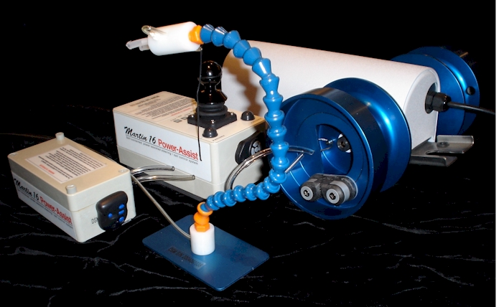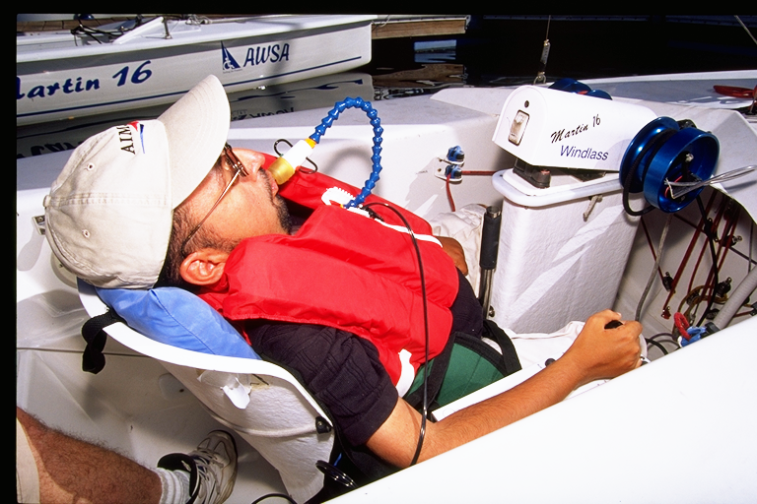

## Operator Manual

## Congratulations!

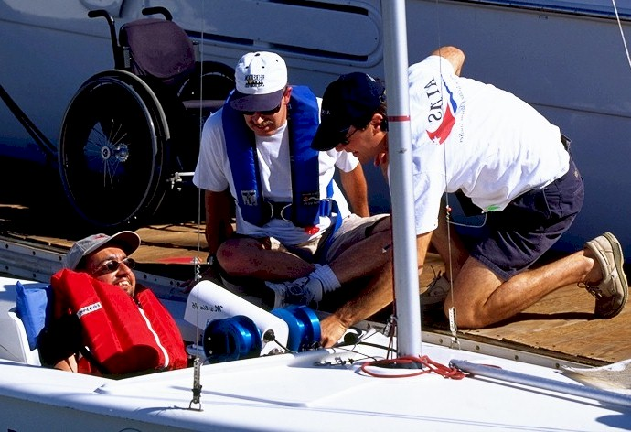

## The vision of the Martin 16 Power-Assist System is to get everyone out sailing. Men, women and children with significant disabilities use a Power-Assist System like yours to enjoy the freedom of independent sailing, by providing power-assisted steering and sheeting for the Martin 16 sloop, through a familiar joystick or sip & puff interface

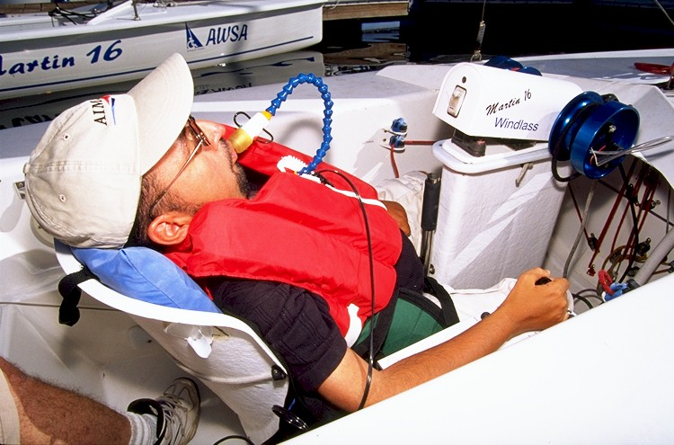

## Everything that you need to know about how to install, operate and care for your Power-Assist System is in this Operator Manual. If it’s not – give me a call!

***Fair Sailing!***

Steve Alvey 403-870-7210

## Warning to Operator

The Martin 16 Power-Assist System is an ASSISTIVE DEVICE, intended to assist sailors with limited hand function to operate sailboats independently.

The fabricator provides no specific warranties or claims of the Martin 16 Power-Assist System’s "fitness for use" for any person, on any vessel or sailing conditions. Sailing is a dangerous sport, and the operator uses the Martin 16 Power-Assist System at his/her own risk. Operators are responsible for receiving proper training in the use of the Martin 16 Power-Assist System and for taking normal and appropriate precautions while using the system.

Always have able-bodied person on board your vessel so that, in conditions of inclement weather or when emergency maneuvers are required, they may disengage the Martin 16 Power-Assist System and steer the boat manually. If the Martin 16 Power-Assist System malfunctions for any reason while sailing, always be prepared to revert to manual steering control.

##### *Table of Contents*

**Martin 16 Power-Assist System**

A Brief History 3

Joystick Module 4

Sip & Puff option………………………………………………………………….. 5

Windlass 6

Battery Module / Intelligent Battery Charger 7

Upper Body Support Harness 7

**Power-Assist System Features & Operation**

Joystick Module 8

Connectors 8

Power 9

Power, Battery, and Joystick LEDs 9

Sip & Puff (option) 10

Pneumatic Connections 10

**When you first receive your Power-Assist System**

System Test components on land 11

**Installing the Power-Assist System on a Martin 16 for the first time**

Install the Pedestal (Part # D030) 13

Install the Tiller Cross Arm and Tiller Rod 14

Adjusting the length of the Tiller Rod 15

**Installing the Power-Assist System each time you go sailing**

Charging the battery 16

Install the Windlass: 17

Install the Power-Assist Joystick Module: 18

Install the Helm Drive Motor 19

Donning the Upper Body Support Harness 20

**Before you go sailing**

Adjust the JIB SLOT TRIM sheet 21

Check (manual) Joystick is Centered 22

Check Tiller Rod is Centered 22

Check Sip&Puff Module operation 22

**WARNING TO OPERATOR 23**

**Caution while sailing 24**

**Caring for your Martin 16 Power-Assist System 25**

Warranty 26

**Appendix A: Spare /Replacement parts** 27***M16 Power-Assist System – a Brief History***

## The idea for sip & puff controls for a sailboat came from Sam Sullivan, a quadriplegic and founder of the Disabled Sailing Association. Sam had seen high quads operate their wheelchairs by sip & puff, and envisioned that this technology might be used to control a sailboat. The world’s first sip & puff control system for a sailboat was designed by the Neil Squires Foundation (Vancouver, Canada) and installed on a Sunbird sloop the “Royal Spirit”. The Royal Spirit debuted at the Mobility Cup regatta in 1994.

## The sip& puff technology was adapted to the new Martin 16 sloop in 1998 under the “Royal Bank Project”. Steve Alvey, with DSA Alberta, brought a volunteer Project Team together, several companies donated parts and equipment, and with the financial support of Royal Bank Financial a robust, self-contained system was designed to meet the needs of high-quad sailors. Since that time, Steve has continued to refine the Power Assist System, culminating in the current Mark VI (2021) System.

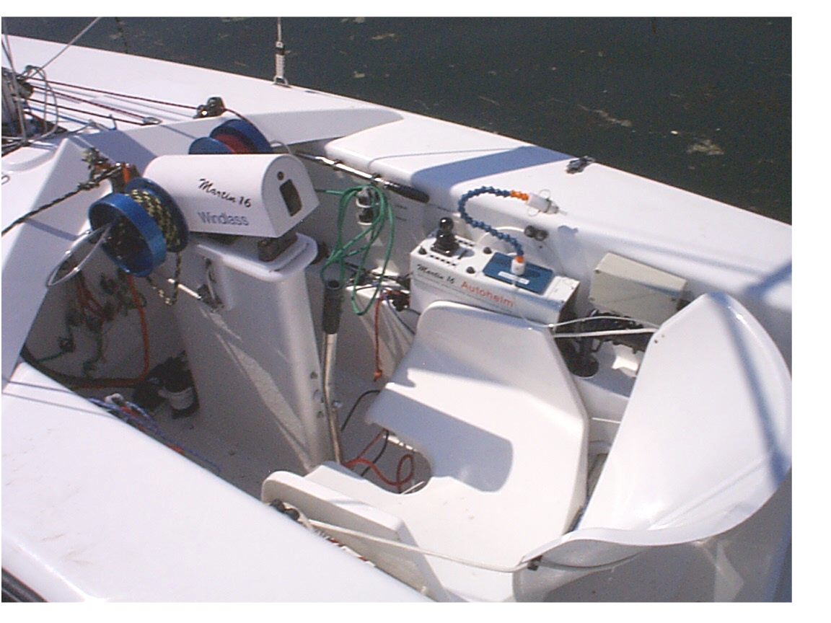

Now, more than 130 Martin 16 Power-Assist Systems are in service around the globe: Canada, USA, UK, Japan, Greece, Netherlands, Sweden, Italy, Israel, Australia, New Zealand and Puerto Rico. At Mobility Cup, Canada’s annual International Regatta for Sailors with Disabilities, sailors with high-level quadriplegia - using a Power-Assist System - compete on the same starting line with other sailors.

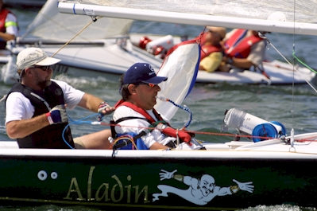

The Power-Assist System has changed the lives of these sailors, and more like them each new season.

## M16 Power-Assist Joystick Module

***Self-contained, portable, weatherproof system components*** *are intended for outdoor use in marine environment. The Power-Assist System can be installed in minutes on any standard Martin 16 sloop, or any other tiller-steered sloop (Freedom 20, Sonar, Catalina 22, etc.).*

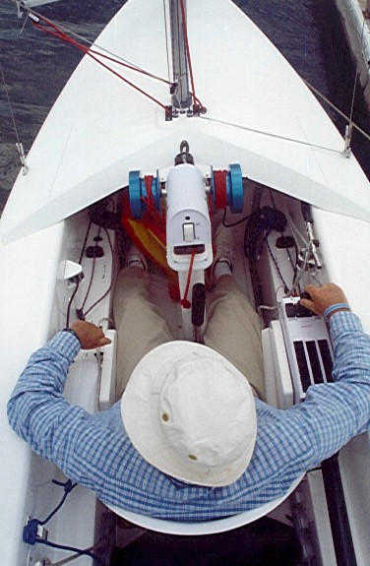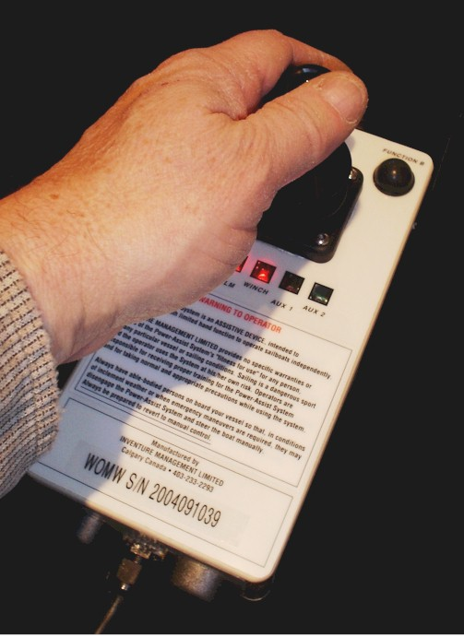

* ***Power-Assist Joystick Module*** *contains a control computer and a joystick control in a weatherproof enclosure. The Joystick Module is light and can be positioned comfortably beside the sailor – to the left or right – or on the sailor’s lap if necessary. The Joystick Module offers a familiar, wheelchair-like operation.*
* ***Any 12V power source*** *can provide power to the Joystick Module: 1) the portable Power-Assist Battery Module or 2) a “house battery” on boats equipped with 12V DC power.*
* ***Emergency Disengage*** *of the EV100 helm drive in the case of system malfunction is provided via a “quick-release” pin that can be operated from the rear seat of the Martin 16. (Note: Emergency Disengage is NOT accessible to helmsperson).*

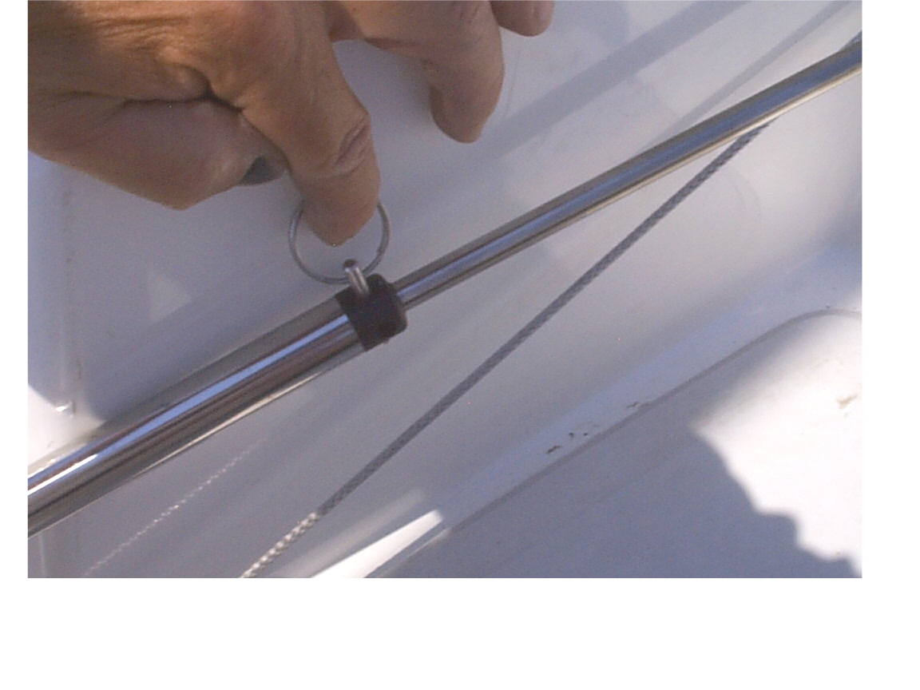

## M16 Sip & Puff (option)

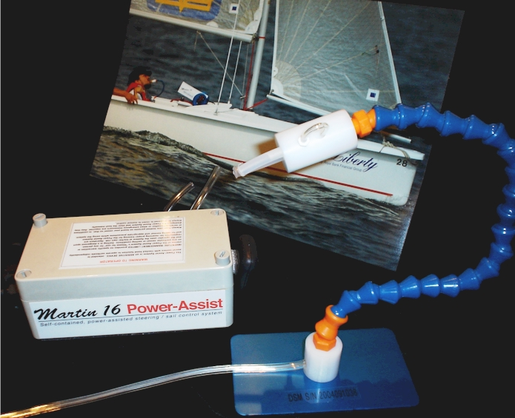

* ***Sip & Puff Module*** *provides a sensitive pneumatic control interface, allowing high-quadriplegic sailors to control the Power-Assist System functions using their breath.   
    
  The sip & puff interface is a chest-mounted control “stalk”. The stalk positions two pneumatic “straws” within reach of the sailor’s lips: one to control the HELM and one to control the WINDLASS.*
* ***Optional at time of order:*** *when you order your Power Assist System, you can specify the Sip & Puff option to be added to your Joystick Module.*

## M16 Windlass

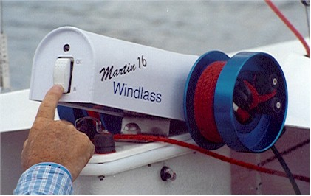

* ***Martin 16 Windlass*** *is a self-contained, portable power winch system for the main and jib sheets of any standard Martin 16 sloop. The Windlass may be used stand-alone or in conjunction with the Power-Assist Joystick or Sip&Puff Control Module. The Windlass installs in minutes on top of the Martin 16 keel, and main and jib sails are trimmed in unison via either a large toggle switch on the rear panel of the Windlass enclosure, or remotely by the joystick or sip & puff stalk.*

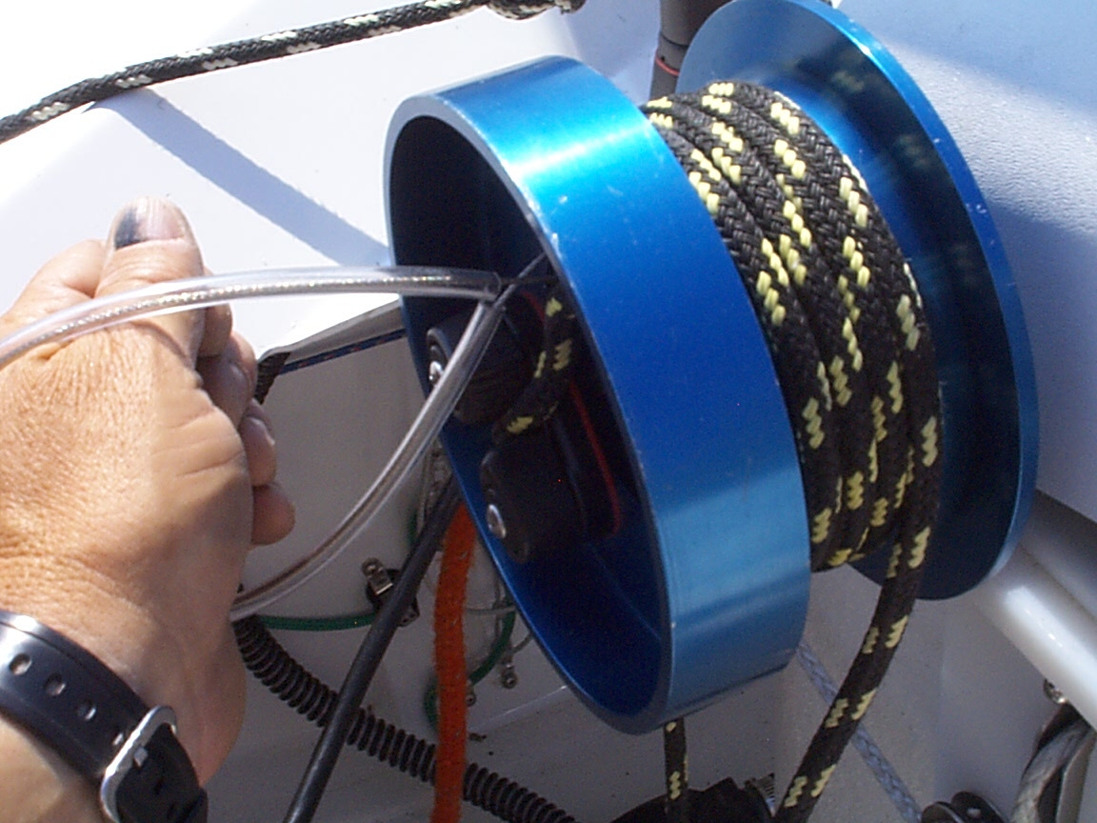

* ***Emergency Release*** *of the sheets in the case of system malfunction is provided on both winch drums via a “quick-release” pin that can be operated with minimum manual dexterity.*
* ***Any 12V power source*** *can provide power to the Sip & Puff Module: 1) the portable Power-Assist Battery Module or 2) a “house battery”  
   on boats equipped with 12V DC power.*

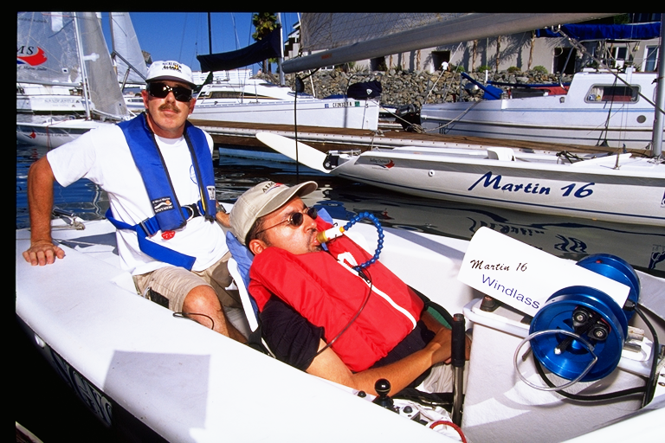

## M16 Power-Assist LITHIUM Battery Module

* ***Portable Battery Module*** *houses an 7AH LITHIUM battery which provides from 4 - 6 hours sailing time before re-charging. The Battery Module may be used to power 1) Joystick Module, and/or 2) Windlass.   
  When not in use, a compact Lithium Battery Charger maintains the battery’s condition and ready for your next sailing session.   
  (Note: APPROXIMATE battery life, as sailing conditions vary).*

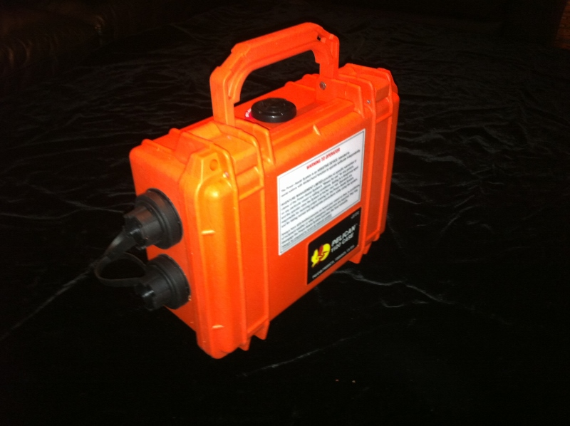

* ***Intelligent Lithium Battery Charger*** *is matched to the LITHIUM battery technology used in the Battery Module.*
* *compatible with any electric system in the world*
* *will charge battery to full capacity in less than three hours*
* *UL, CSA and CE Approved.*

## M16 Upper Body Support Harness

* *The* ***Upper Body Support Harness*** *may be worn by paraplegic, quadriplegic or hemiplegic sailors in weather and sea conditions where additional upper body support is required. The Upper Body Support Harness is made of robust webbing with industrial quick-release velcro fastenings. It can be adjusted to fit any sailor, and used on the Martin 16 as well as other adapted sailboats (and powerboats) wherever suitable anchor points can be arranged to each side of the sailor.*

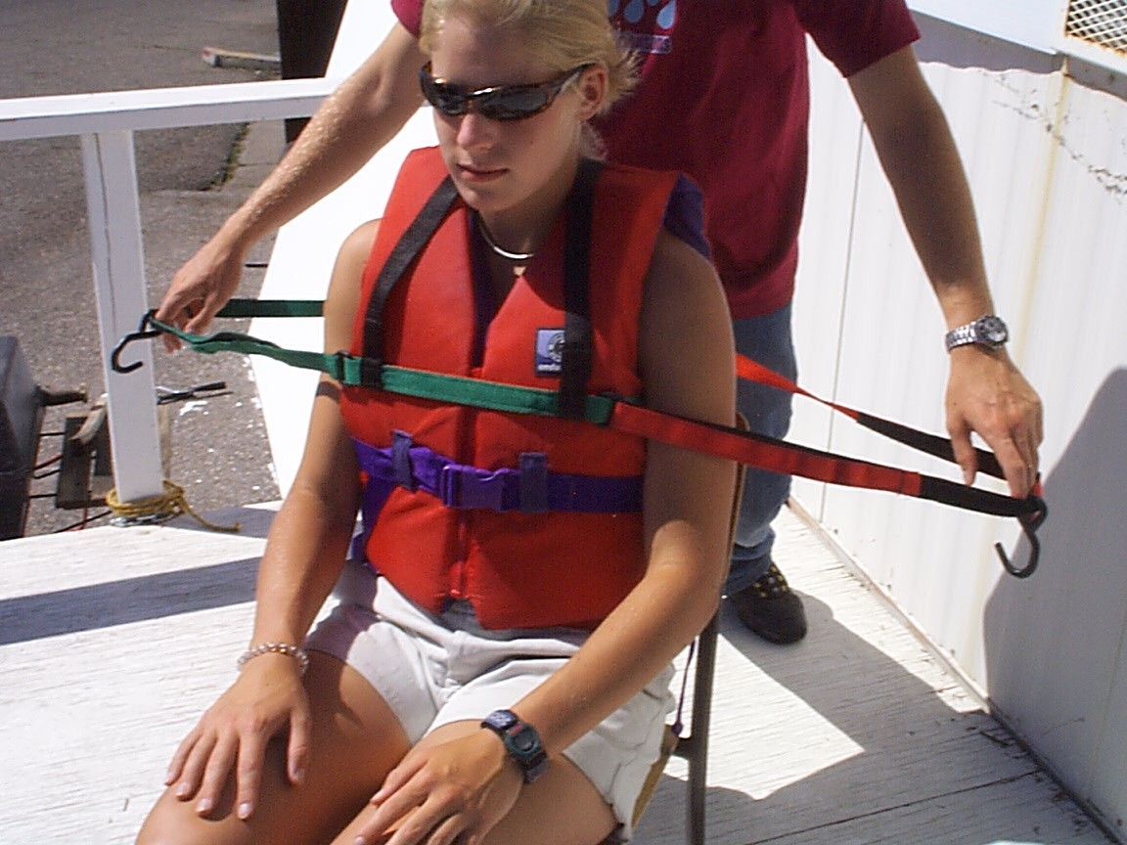

## M16 Power-Assist System Features & Operation

## Joystick Module

**CAUTION:** ENSURE THAT ANYONE USING THE POWER-ASSIST SYSTEM IS ORIENTED IN ITS OPERATION AND CARE. We recommend that ONE PERSON be made responsible for your system’s care and maintenance.

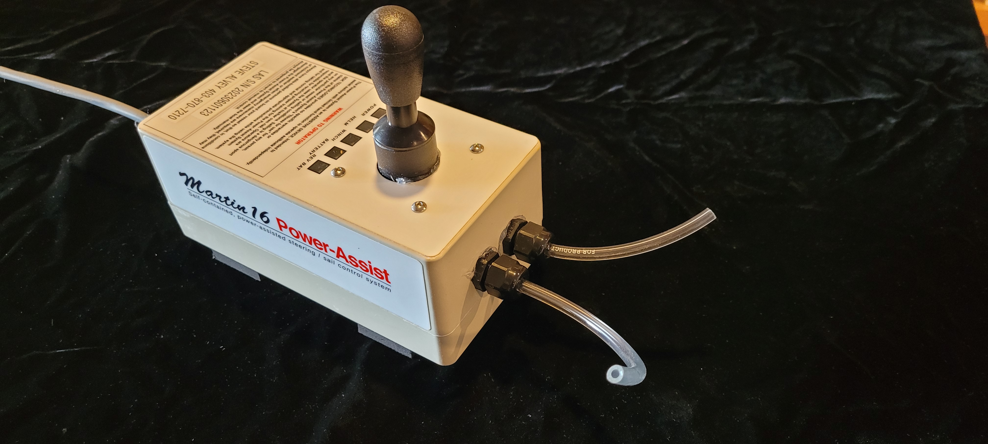

The **Joystick Module** is programmed to accept control inputs from the **joystick** or, optionally, **Sip&Puff,** to control the HELM DRIVE or WINDLASS.

**Joystick Module - Connectors**

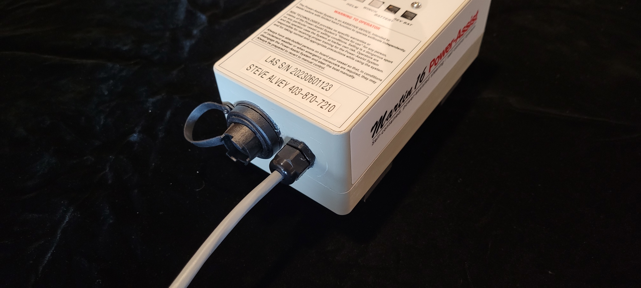

The Power-Assist Joystick Module has a water-resistant 3-pin Bulgin connector on the rear panel of the enclosure, to connect the EV100 helm drive. This connector is keyed and care must be taken to insert and lock the connector in place.

**Care of Connectors**

To assure reliable operation, IT IS IMPORTANT TO CARE FOR CONNECTORS, to maintain their electrical integrity and to assure that no water enters the Joystick Module enclosure.

* Check that the **weather-proof protective caps are snugly installed** over un-used Power-Assist Helm connector at all times on and off the water.
* The **Power cord connector has a KEY** that fits only one way into the Battery Module port. Before inserting the plug, locate the KEY and align it with the connector KEY. Seat firmly and screw the retainer ring on until hand-tight.
* Maintain connectors by cleaning them and spraying with a moisture displacement fluid (Boeing BOESHIELD T-9 is ideal. You can buy it at WEST MARINE).
* Before you insert any connector, check that it is free of water, dirt and/or sand. Clean it with fresh water if required and spray with BOESHIELD.
* When transporting the system, be careful not to drag the cords and connectors along the ground or through sand and dirt.
* When seating 3-pin connectors, make sure that they seat firmly, and do not force the fit.

**Joystick Module - Power**

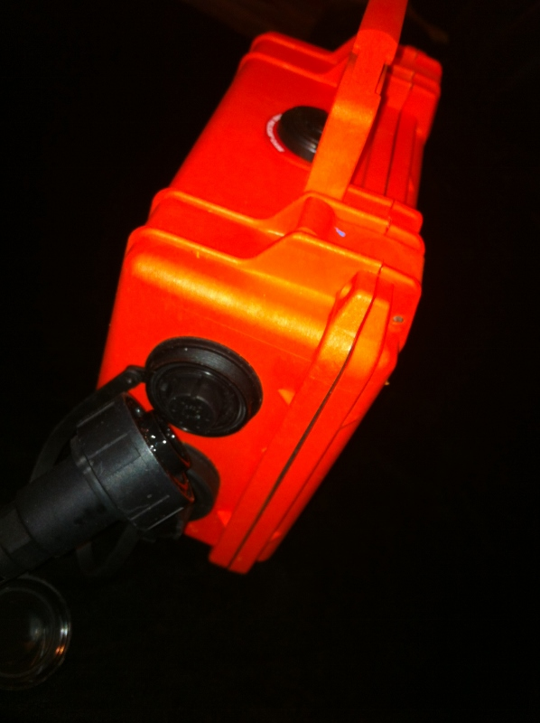

The **Joystick Module** is powered up when you plug the power cord into the **Battery Module** – there is no power switch.

The **power cord connector has a KEY** that allows it to fit only one way. Before inserting the male plug, locate the KEY and align it with the connector KEY. Seat firmly and screw the retainer ring on until hand-tight to secure the power cord, so that power will not be accidentally switched off while sailing.

To turn the power OFF, you must disconnect the **Joystick Module** power cord from the Battery Module.

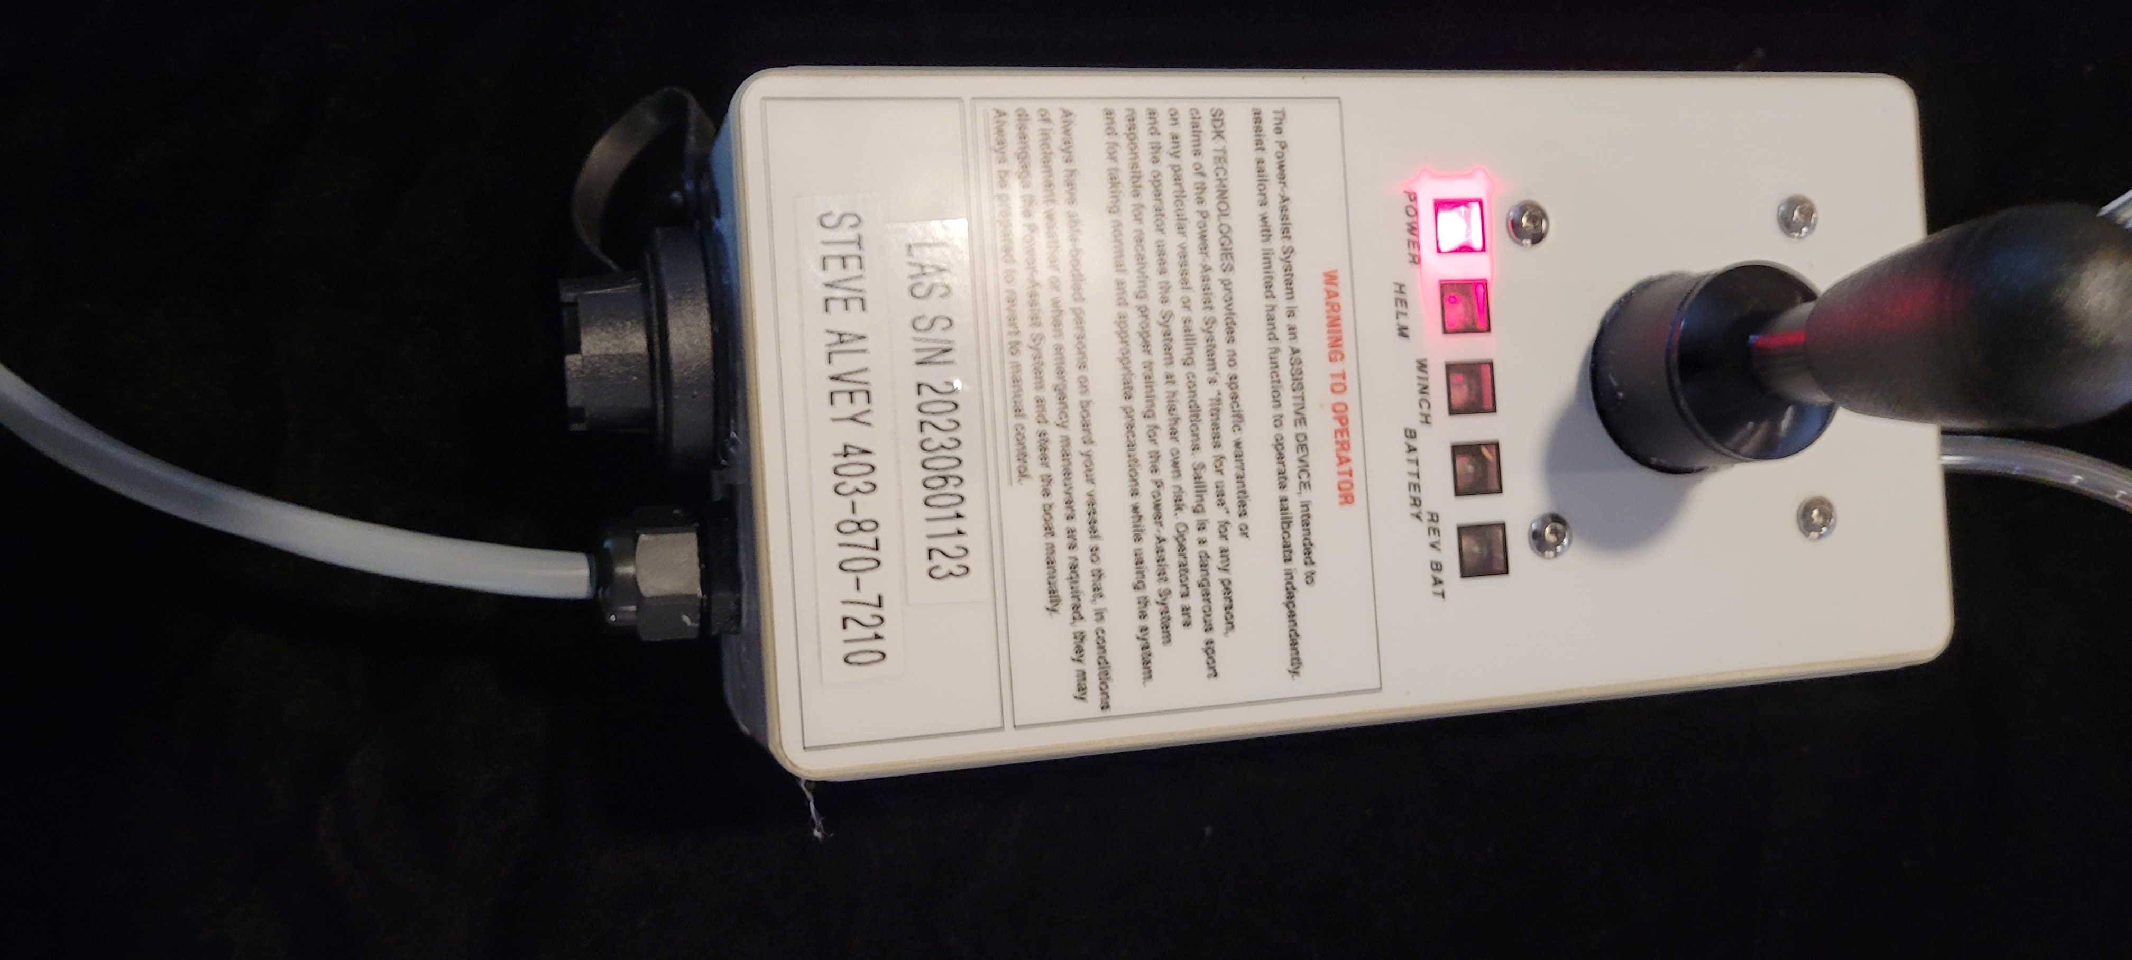

**Power LED**

Below the joystick you will see a blinking, red LED to indicate that power is ON.

**Battery LED**

The Battery LED indicates when the battery needs to be recharged. It is normally OFF. When the battery is discharged, it will BLINK to indicate the battery is on reserve power. Recharge the battery soon.

## Joystick LEDs

The sailor uses the JOYSTICK to control the HELM DRIVE MOTOR or WINDLASS:

* **LEFT / RIGHT axis**: of the joystick operates the Helm Drive Motor to steer the Martin 16. Pushing the JOYSTICK - LEFT, will turn the Martin 16 to the LEFT. Similarly, pushing the JOYSTICK - RIGHT will turn the rudder to the RIGHT. Releasing the joystick will leave the rudder in its current position.

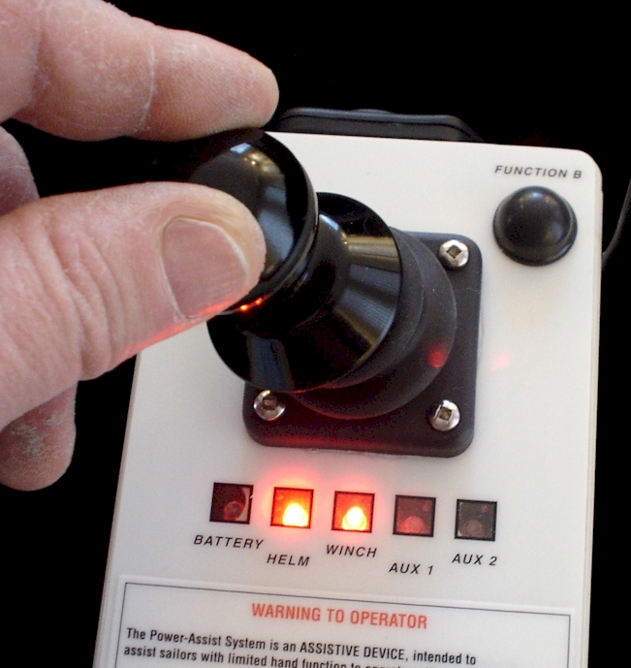

* **FORWARD / BACKWARD axis** of the joystick operates the WINDLASS. Pushing the JOYSTICK – FORWARD will LET THE SAILS OUT. Similarly, pulling the JOYSTICK – BACKWARD will PULL THE SAILS IN.

## Sip & Puff Option

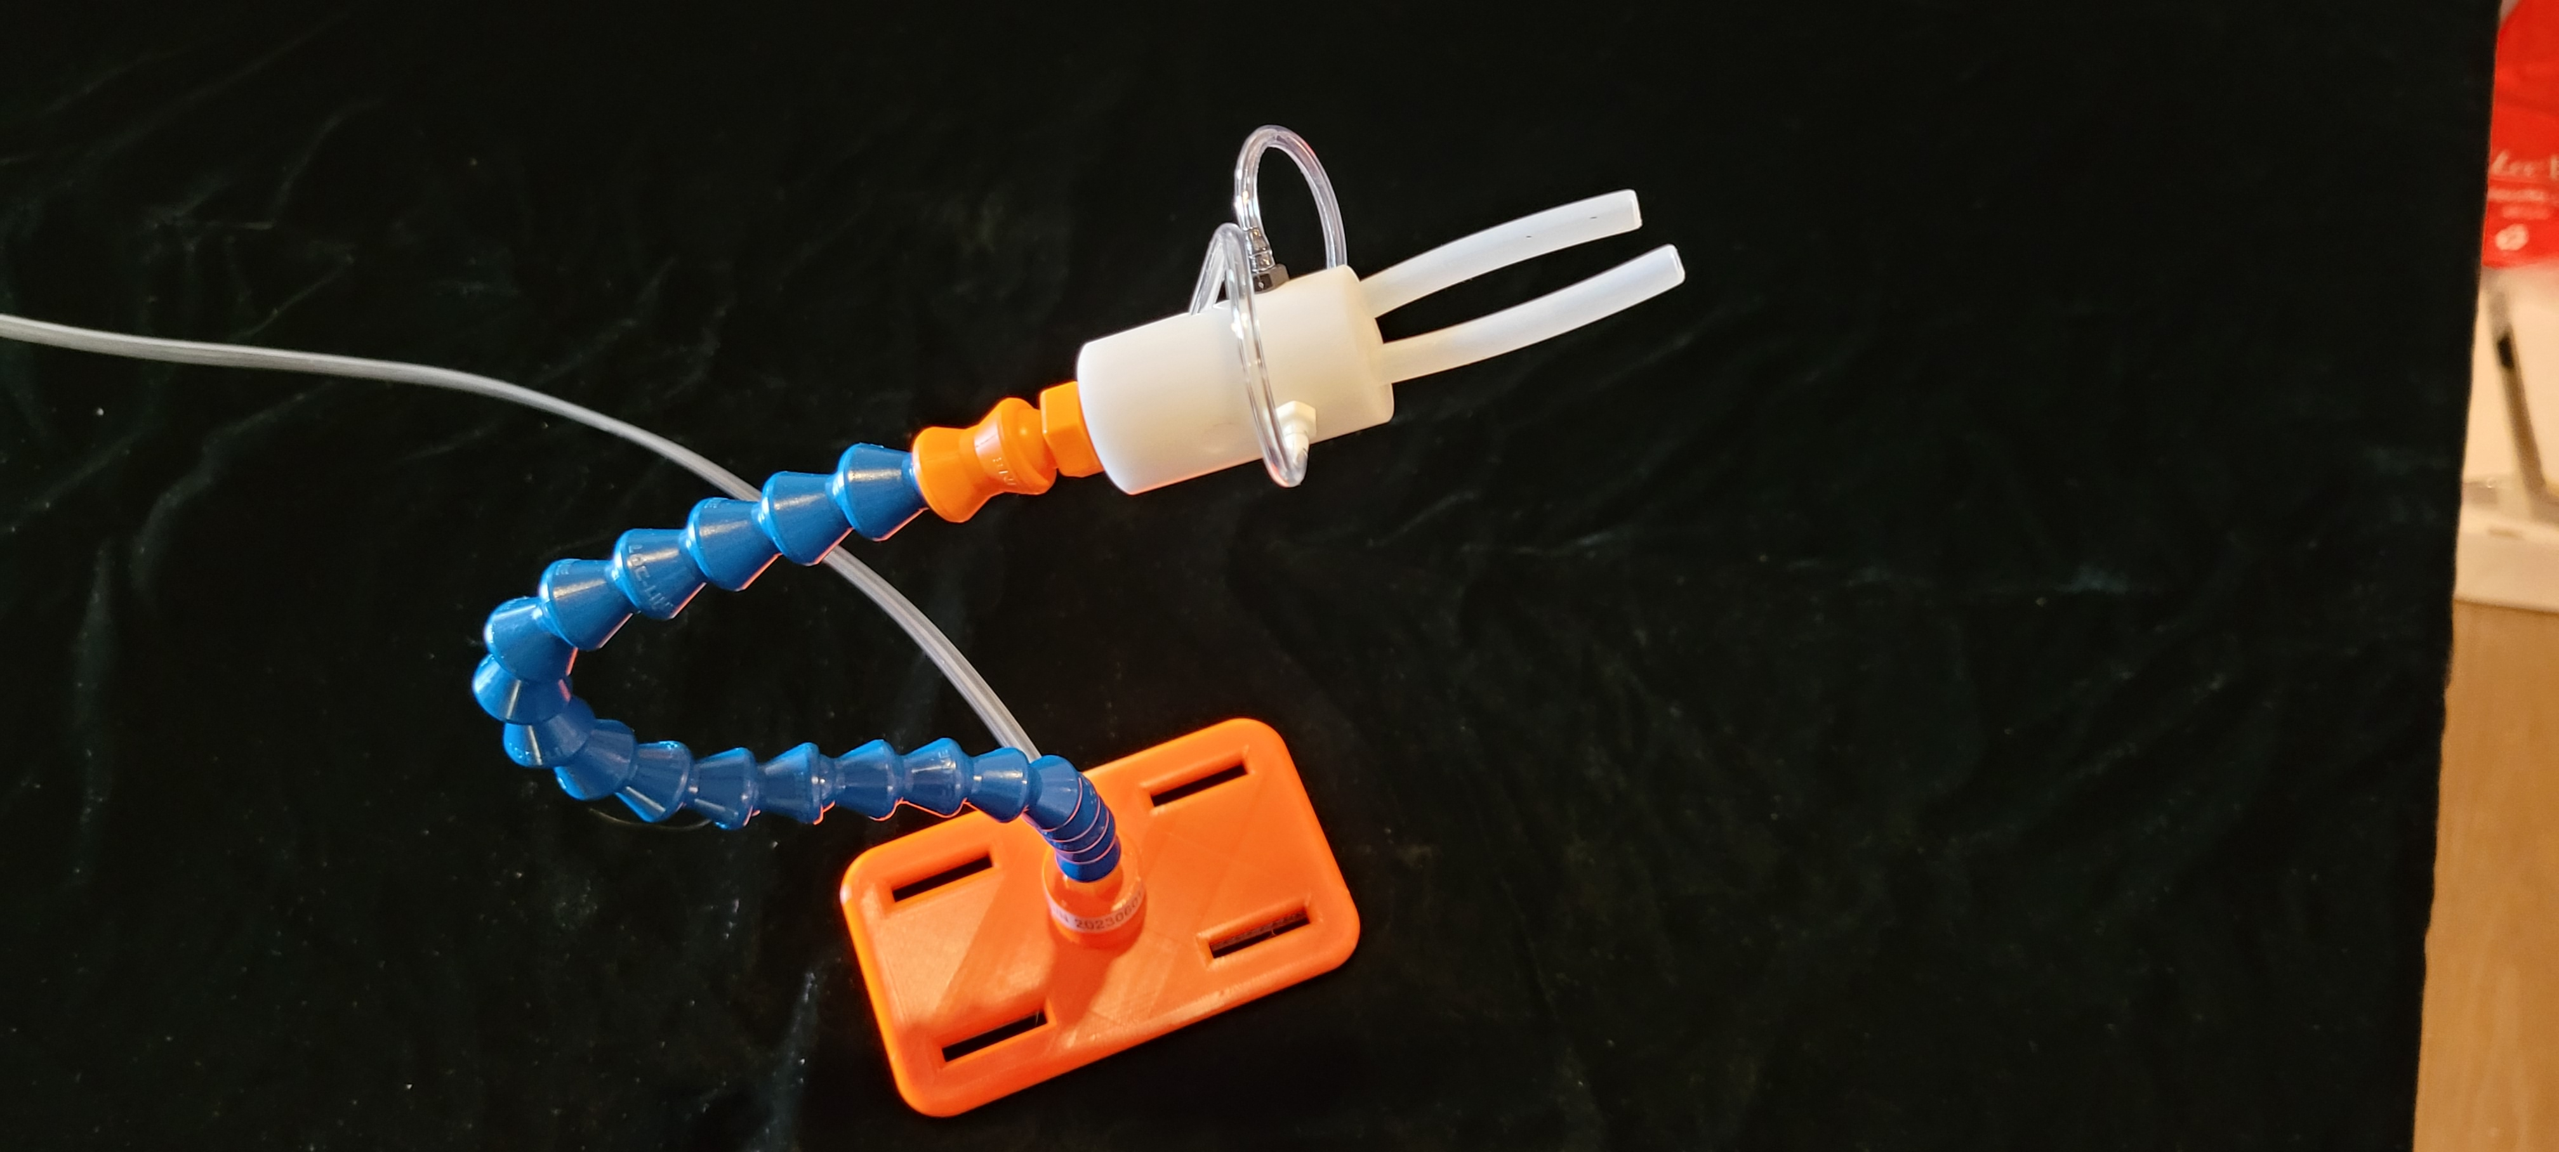

The optional **Sip & Puff Module** provides a pneumatic control interface, allowing high-quadriplegic sailors to control the helm and the Windlass using their breath. The **Sip & Puff Module** interface is a chest-mounted control “stalk”. The stalk positions two pneumatic “straws” within reach of the sailor’s lips: one to control the HELM and one to control the WINDLASS.

**Sip & Puff Module – Pneumatic Connections**

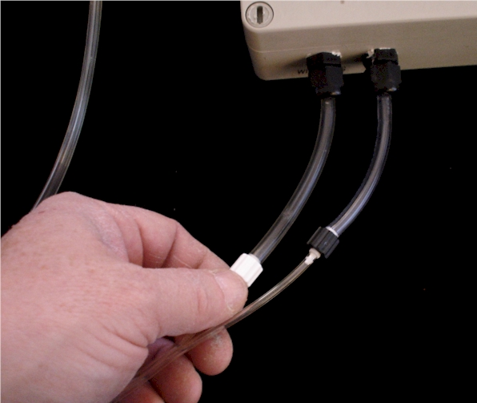

*The pneumatic tubes on the Sip & Puff Chest Stalk are connected to the tubes on the Sip & Puff module. Once connected, they can be left connected as convenient for the sailor. Here’s how you connect the tubes:*

* *Gently press the LUER fitting on the end of the tubing directly into the 1/8” tubing on the Sip&Puff Module. Work this fitting into the tube snuggly. Then hand tighten the knurled nut on the LUER fitting (BLACK and WHITE nuts). Once connected, test the operation of the system.*

**CAUTION: Sip & Puff module is recommended for “personal use” only.**   
The components of the Sip & Puff Module encounter the user’s mouth, breath, saliva and other body fluids. Since disease can be transferred through body fluids, medical practice recommends that the Sip & Puff Stalk and the Sip & Puff Module be reserved for personal use (i.e. one Stalk/Module for each user). The user of the Sip & Puff stalk should always clean the stalk parts with denatured alcohol prior to use. Inspect the tubing for trapped moisture or saliva and disassemble and clean as required. The Operator is responsible for appropriate use of the Sip & Puff module components and the associated medical risks.



## When you first receive your Power-Assist System…

Your Power-Assist System has been system tested before being shipped to you. To familiarize yourself with the system, when you first receive your Martin 16 Power-Assist System:



* **Verify the System components** against the packing slip enclosed with your system. Each component has your serial number on it.
* **Check for shipping damage**
* Become familiar with and then connect all of the components and perform the following **System Tests** on land.
* **Problems? Call Steve Alvey at 403-870-7210**

## System Test components (on land)

***If you have not already done so, take the time to read the System Features and Operation sections of this Manual.***

*Gather the components of your Power-Assist System and place them on a clean surface. Place the Windlass on a soft towel for system tests. This will stop the winch drums from getting scuffed during testing.*

*Identify the* ***Power-Assist Connectors*** *on each of the Battery Module, Joystick Module, Windlass, and Helm Drive. They are keyed to prevent misconnection. See if you can connect the system components together…*

***Identify and connect System Modules:***

* *Connect the Windlass power cable to the 6-pin connector on the Battery Module*



* *Joystick Module power cord to the 6-pin connector on the Battery Module*
* *Helm Drive motor to HELM DRIVE connector on Joystick Module*
* The Power LED in the Joystick Module will be illuminated, indicating power is ON.
* Once you have a WINDLASS connected, the Windlass LED will be illuminated.

**Test Joystick operation**

Operate the JOYSTICK on the Power-Assist Joystick Module:

* **LEFT / RIGHT axis** of the joystick operates the Helm Drive Motor to steer the Martin 16. Pushing the JOYSTICK - LEFT, will extend the Helm Drive. Similarly, pushing the JOYSTICK – RIGHT will retract the Helm Drive.
* **FORWARD / BACKWARD axis** of the joystick operates the WINDLASS. Pushing the JOYSTICK – FORWARD will operate the Windlass motor. Looking at the Windlass from the right side, the drum will rotate counter-clockwise. Similarly, pulling the JOYSTICK – BACKWARD will rotate the drum clockwise.

**Test Sip & Puff operation**

**CAUTION:**  CLEAN THE SIP & PUFF STALK WITH ALCOHOL BEFORE AND AFTER USE. Connect the Sip & Puff power cord to the Battery Module, and operate the SIP & PUFF Module functions as follows:

* **HELM LEFT / RIGHT:** Operate the Helm Drive motor by gently sipping and puffing on the Sip & Puff stalk. The Helm Drive motor should respond promptly to the pressure of your breath. SIPPING retracts the Helm Drive. PUFFING extends the Helm Drive.
* **WINDLASS IN / OUT:** Operate the WINDLASS motor by gently sipping and puffing on the Sip & Puff stalk. The Windlass motor should respond promptly to the pressure of your breath. Looking at the Windlass from the right side, PUFFING the straw will rotate counter-clockwise. Similarly, SIPPING the straw will rotate the drum clockwise.

***If any of the system components do not work as described, call Steve Alvey 403-870-7210.***

## Installing the Power-Assist System on a Martin 16 for the first time…

When you first get the system, you have to: (one time)

* Install the **Pedestal Socket Mount** on your Martin 16
* Install the **Tiller Cross Arm** and **Tiller Rod** on the Martin 16 rudder head
* Test the stop-to-stop operation of the **Helm drive**, and adjust as necessary to center.

**Install the Pedestal Socket Mount (Raymarine Part # D030)**

1. *Identify the Pedestal Socket Mount (D030 on package). You’ll also need:*

* *3/8” portable drill and ¼” bit*
* *7/16” open-end wrench (small one)*
* *Large slot screwdriver*
* *Small tube of Sikaflex SEA-L or 241 Marine sealant or equivalent good quality marine sealant, (NOT silicon caulking)*

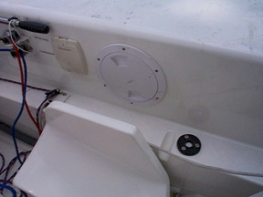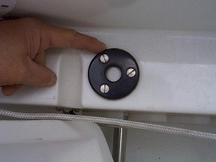

1. *Locate the 6” hatch to the right of the helm seat. Remove the hatch cover. Reach inside the cover and feel the “inner” construction of the cockpit just aft of the “scupper” in the ledge directly to the right of the seat back. You are going to install the pedestal on the ledge, just aft of the scupper.*
2. *Place the pedestal base plate on the ledge by hand. It can be moved around, and you’re going to locate it about ¼” aft of the scupper, and ¼” from the edge of the lower cockpit wall (that runs down to the cockpit floor). You’re choosing a location that’s behind the scupper, but as far forward and to the left on the ledge as reasonable. Don’t locate it too close to these edges, as you have to install it with the backing plate inside the side tank. It will interfere with the inner walls if it’s too close to the edges. READ THIS INSTRUCTION AGAIN BEFORE DRILLING.*
3. *Hold the base plate firmly, and drill three ¼” holes, using the base plate as your drilling guide. Ream the holes a bit to make the bolts fit freely.*
4. *Clean the cuttings away from the holes and put a thin bead of Sikaflex SEA-L around each hole. Put the three ¼” bolts through the holes and then install the base plate on the ledge.*
5. *Reach inside the hull with the aluminum backing plate and slide it over the three bolts. This may take a little fiddling. If it won’t go on, your bolt holes may be crooked and may need to be reamed a bit more. Once on the three bolts, the backing plate should stay there by friction.*
6. *Place a lock washer and 7/16” nut on each bolt (supplied). You have to do this by feel, so DON”T DROP THEM! Once you have tightened the nuts finger tight, place a 7/16” open-end wrench on each nut and tighten bolt with a large slot screwdriver. Don’t go bananas trying to over- tighten the bolts.*
7. *Thread the mount turret into the baseplate. Tighten snugly. Leave the pedestal permanently in place.*

Install the Tiller Cross Arm and Tiller Rod

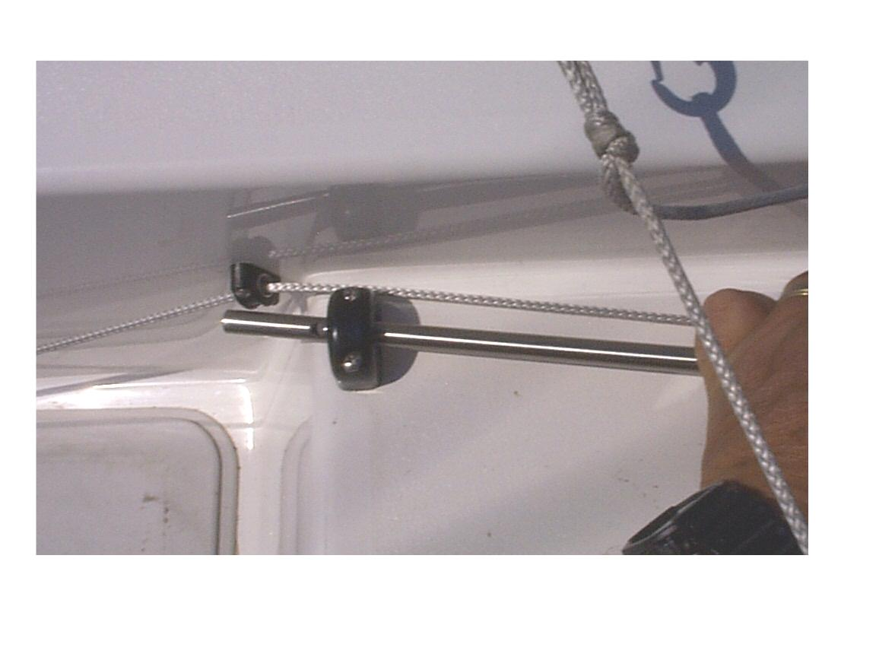

The EV100 drive motor is connected to the Martin 16’s rudder head via the Tiller Rod and Tiller Cross Arm. In most cases, your Martin 16 is manufactured with a Tiller Cross Arm, left permanently in place. The Tiller Rod needs to be adjusted to the correct length before use.

* Lead the front end of the Tiller Rod through the fairlead on the starboard aft deck.

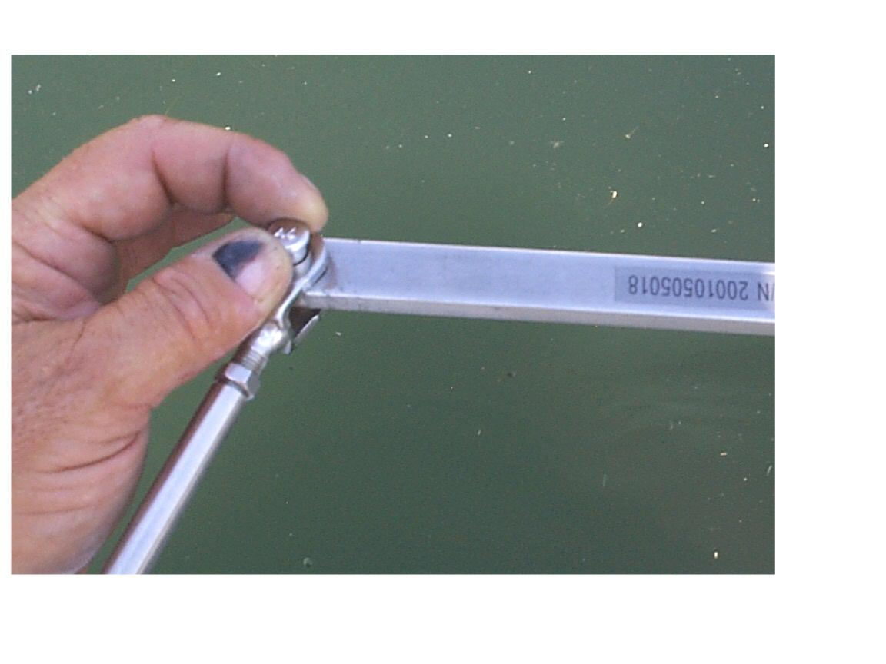

* Install the 5/16 clevis pin and split ring
* The Tiller Rod may be left in place, even when the boat is sailed without a Power Assist System.

**Adjusting the length of the Tiller Rod**

There may be slight variations in the installation of the system from boat to boat, so you have to check the length of the Tiller Rod and adjust as necessary.

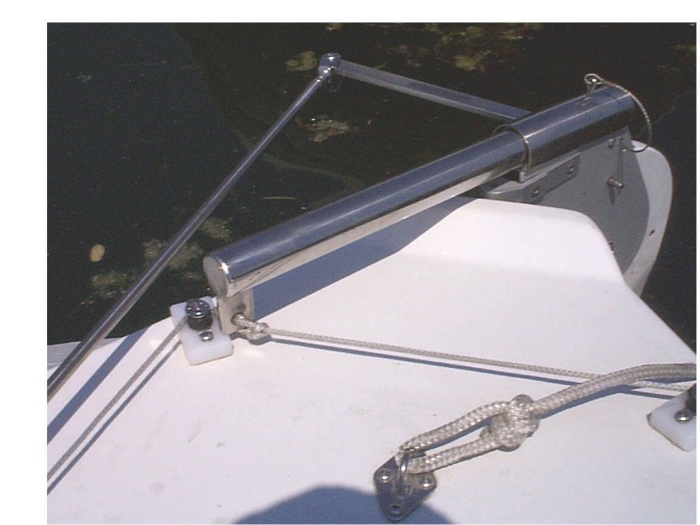

* Once you have installed the system components, turn the Power-Assist System ON. Check that there is nothing in the way of the joystick (the sailor’s hands or legs), tiller or rudder and then operate the joystick to move the rudder all the way to PORT. WATCH THE ACTION OF THE TILLER ROD AND RUDDER and if it seems to be stressed in any way, STOP! If it is adjusted correctly, the M16 Tiller will reach its maximum travel when it is about ½” from the block on the aft deck.

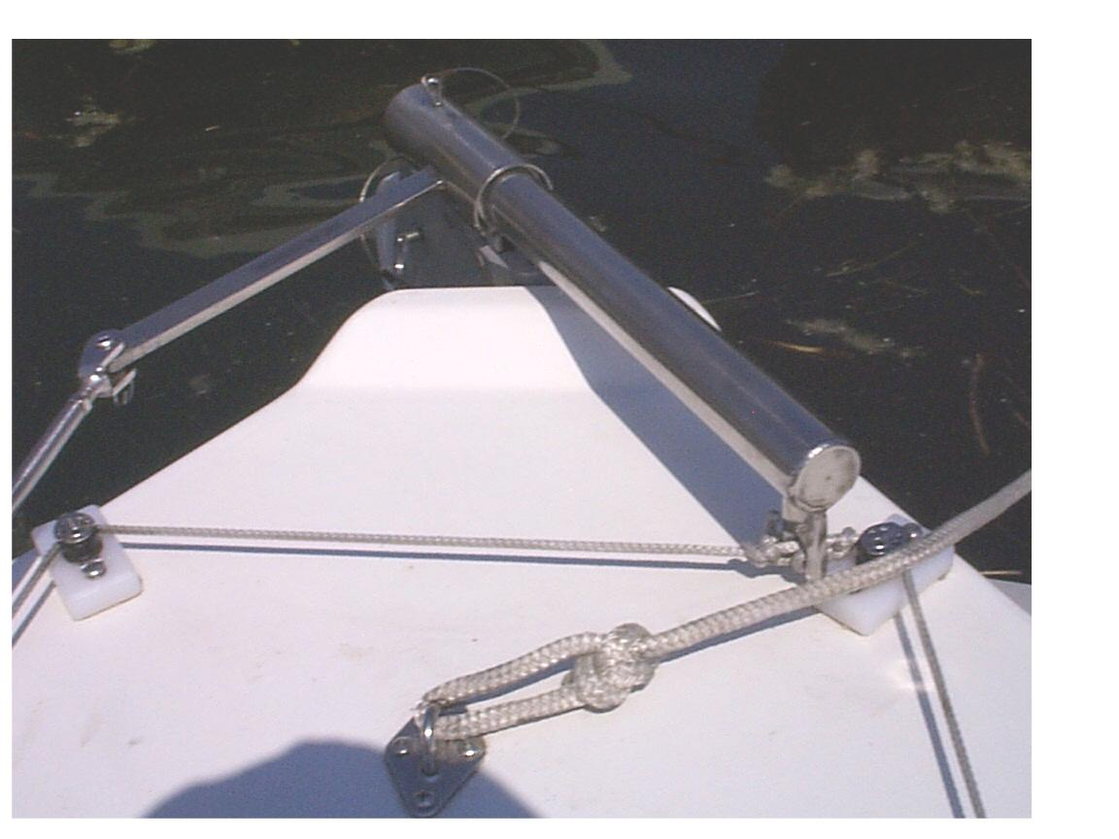

* Now operate the joystick to go all the way to STARBOARD. If it is adjusted correctly, the M16 Tiller will reach its maximum travel when it is about ½” from the block on the aft deck
* If the action of the rudder is not centered (i.e. more to either PORT or STARBOARD), loosen the lock nut on the Tiller Rod and adjust the length of the rod.

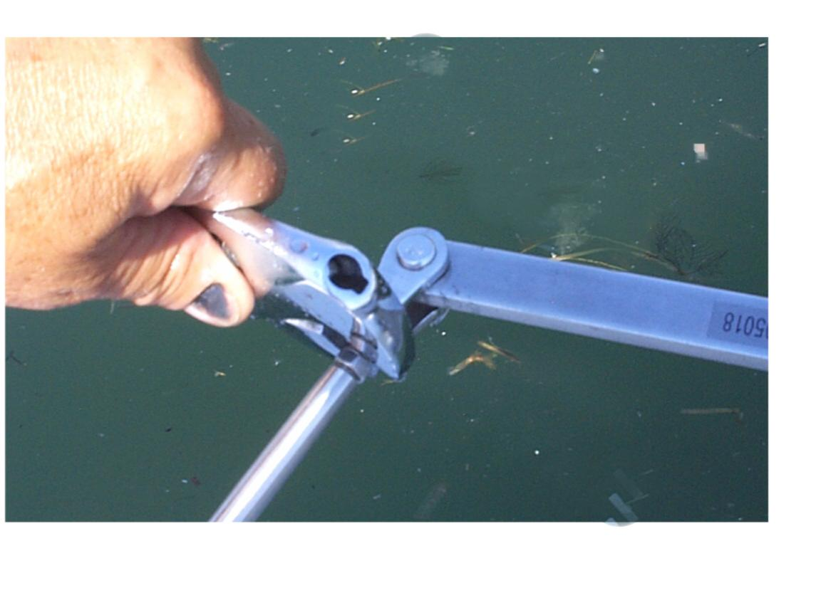

* If it turns TOO FAR TO PORT, make the Tiller Rod SHORTER. If TOO FAR TO STARBOARD, make the Tiller Rod LONGER. Adjust the length of the rod in increments until the action of the rudder is centered, and then re-tighten the lock nut. NOTE: Before tightening the lock-nut, check that the Emergency Disengage FAST PIN is in a VERTICAL position.
* You will not have to adjust the length of the rod again as long as it is used on the SAME BOAT. If you use the Tiller Rod and Tiller Cross Arm on a DIFFERENT BOAT, repeat this adjustment procedure.

## Installing the Power-Assist System each time you go sailing…

## Charging the Lithium Battery Module

* ***Your Power Assist System has a Lithium Battery.***
* ***Intelligent Lithium Battery Charger*** *is matched to the Lithium battery technology used in the Battery Module.*
* *compatible with any electric system in the world*
* *will charge battery to full capacity in less than two hours*
* *will not over-charge the Lithium Battery Module*
* *UL, CSA and CE Approved.*
* *Your* ***Lithium Battery Module*** *should only be charged before sailing. Connect the* ***Intelligent Battery Charger*** *supplied with the Power-Assist system for 4 hours, before each sailing.*
* ***CAUTION:*** *Always use the* ***Intelligent Lithium Battery Charger*** *supplied with the Power-Assist system. NEVER LEAVE A BATTERY MODULE ON CHARGE, UNATTENDED.*
* *When not in use, store your Lithium Battery Module in a cool, dry location. The Lithium Battery Module should be charged before storage, but does not have to be charged while in storage.*
* ***CAUTION:***  *DO NOT leave the Battery Module on charge when in storage*

***Charging a “House Battery”***

* *When using a “House Battery” as the 12V power supply for your Power-Assist System, follow the charging procedure recommended by the manufacturer of the boat’s battery system.*

**Install the Windlass**

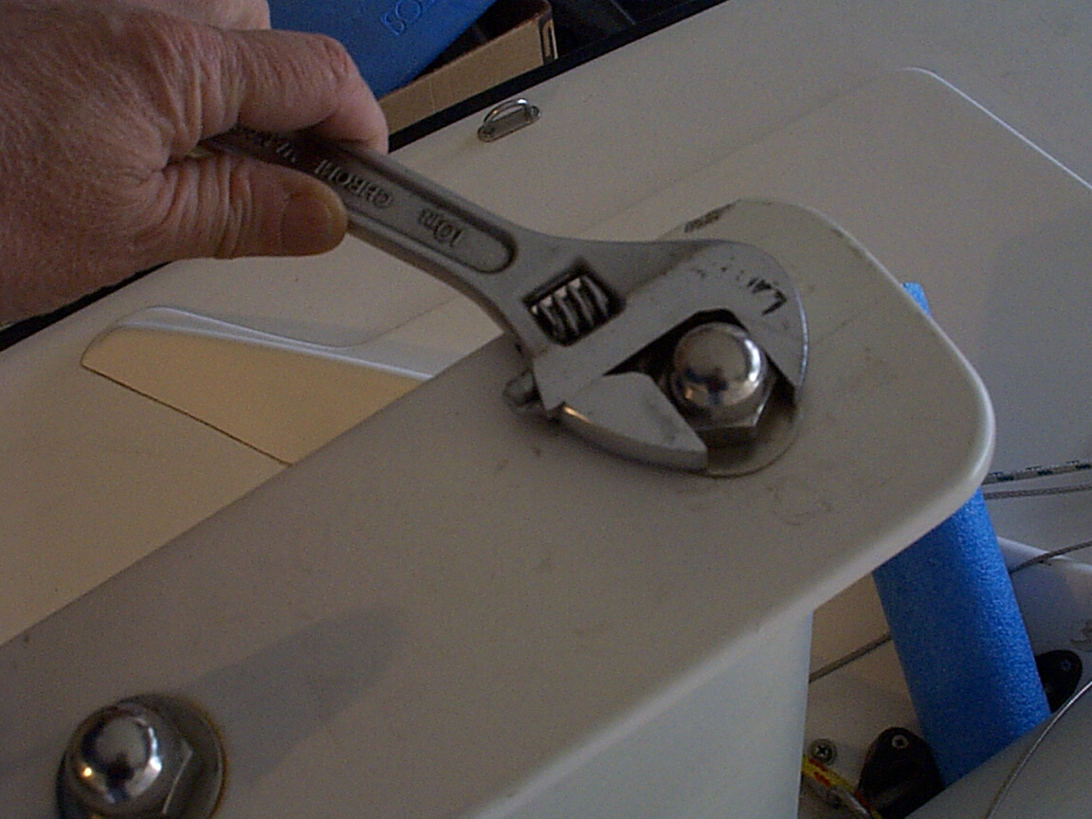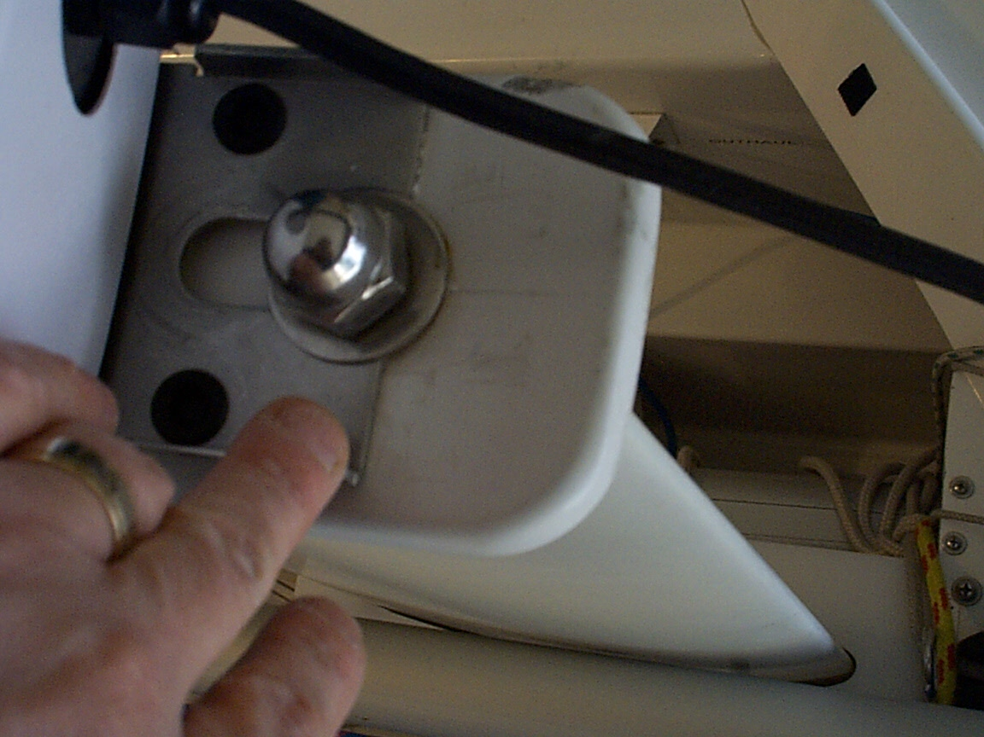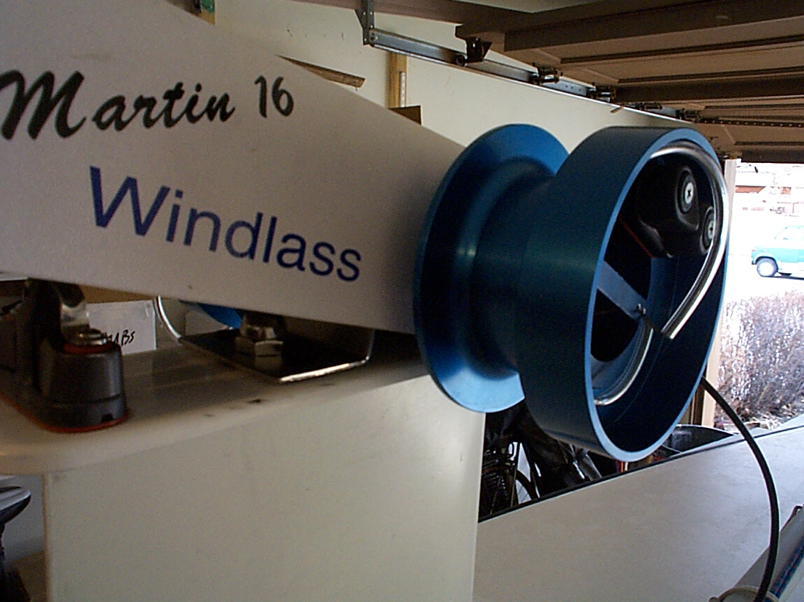

* Undo the figure-eight knots and REMOVE both the main sheet and the jib sheet from their normal position in the MAIN CLEAT on top of the keel plate. Let them hang down loosely from the splash deck fairleads.
* Loosen the FRONT keel bolt nut with a large crescent wrench. Undo the nut three or four complete turns so that it is very loose.
* Slide the “jaw” of the Windlass chassis UNDER both the NUT & WASHER of the front keel bolt. When the jaw is far enough forward, the aligning hole in the back of the Windlass chassis will slip over the REAR keel nut, and the Windlass will be sitting on top of the keel plate.
* TIGHTEN the front keel nut snuggly with an adjustable wrench.
* Now pick up the free end of the MAIN SHEET and feed it UNDER the winch drum and immediately through the hole in the flange towards the HARKEN CLEAT on the flange. Pull 12” of rope through the hole and then cleat the rope in the HARKEN CLEAT and stuff the loose end into the center of the drum.

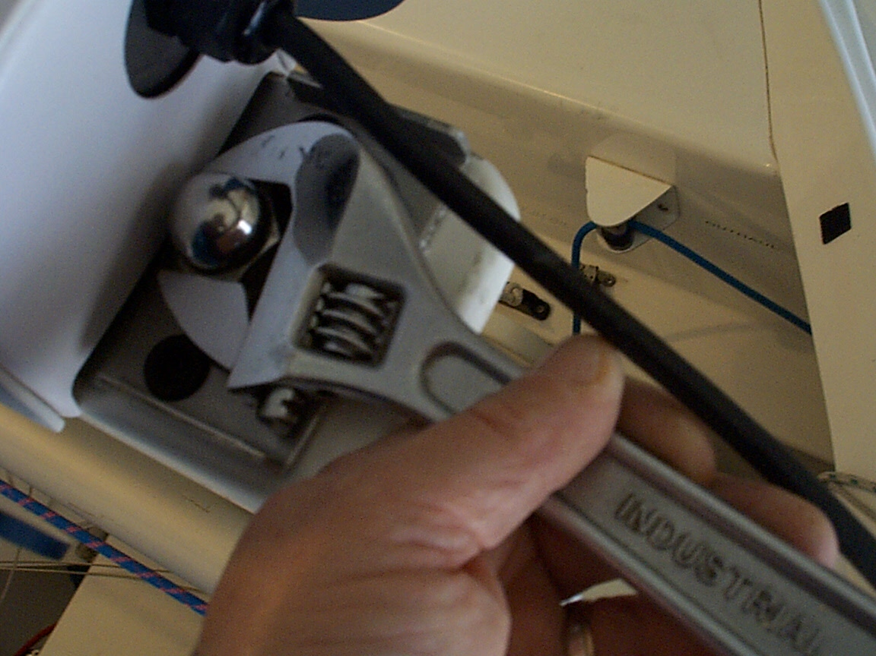

* Then pick up the free end of the JIB SHEET and feed it UNDER the winch drum and immediately through the hole in the flange towards the HARKEN CLEAT on the flange. Pull 12” of rope through the hole and then cleat the rope in the HARKEN CLEAT and stuff the loose end into the center of the drum.

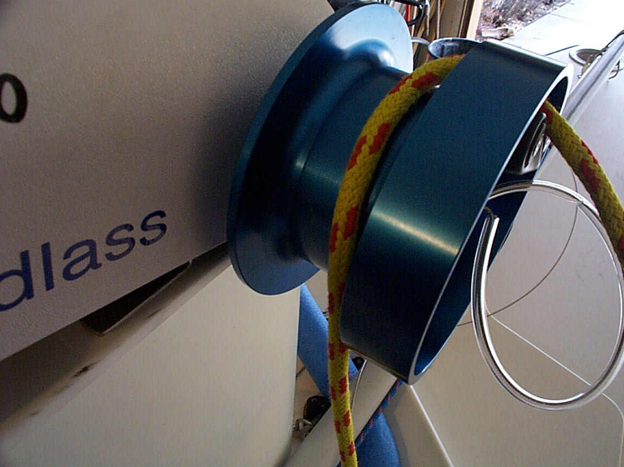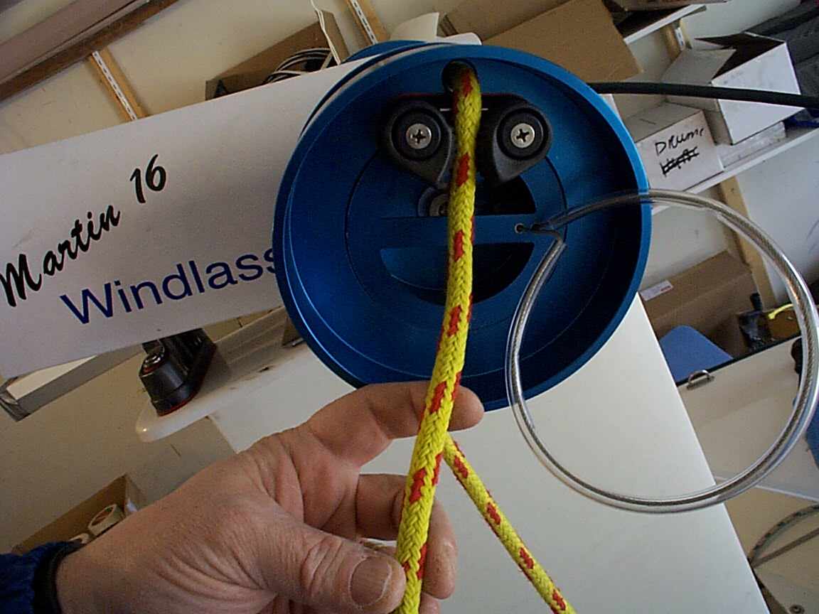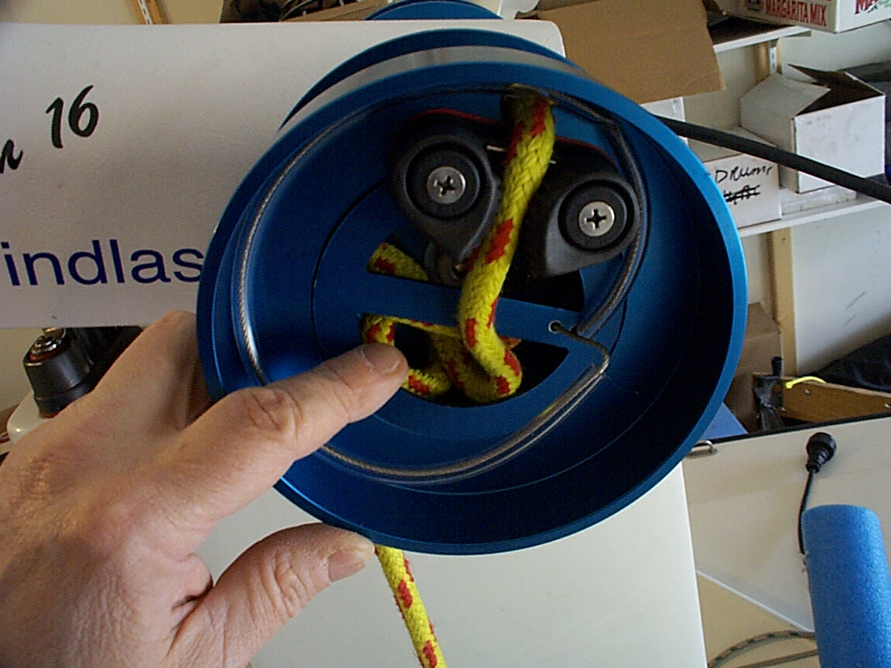

* Under normal operation, the winch drums spool the sheets UNDER and UP THE BACK of the drum when sheeted in. NOTE THAT THE SAILOR CAN OPERATE THE WINCH LONG ENOUGH, SUCH THAT THIS BECOMES REVERSED. If the winch appears to be working “backwards”, this is what has happened. Simply operate the winch OUT to unspool all of the sheet and then continue in that direction to spool the sheets UNDER and UP THE BACK of the winch drums.

**Install Power-Assist Joystick Module**



* First, determine the size of the sailor and then adjust the seat fore-and-aft slot position and approximate height. This is easier to do BEFORE you install the Power-Assist Joystick Module.
* Ask the sailor if they want the Power-Assist Joystick Module positioned for RIGHT HAND or LEFT HAND operation. Place the Power-Assist Joystick Module on the deck (RIGHT or LEFT).
* Place the Battery Module to the side of the seat, opposite the Joystick Module.
* Route the Windlass power cable down into the cockpit INSIDE the main or jib sheet fairlead and then back to connect to the Battery Module. NOTE: The connector is KEYED to fit only one way. Line up the key, push it in fully and then tighten down the locking ring snuggly.

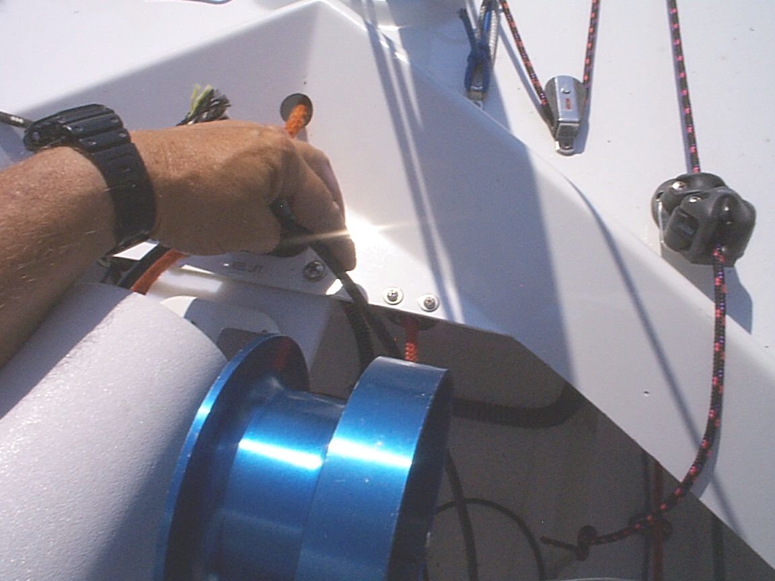

* CHECK that the protective caps for all other connectors are snuggly in place. IF THEY ARE NOT, THEY MAY ALLOW WATER INTO THE POWER-ASSIST JOYSTICK MODULE ENCLOSURE.
* Place the Power-Assist Joystick Module on the shelf to the left or right of the sailor’s seat, about 2” – 3” ahead of the pedestal.

**Install the HELM DRIVE Motor**

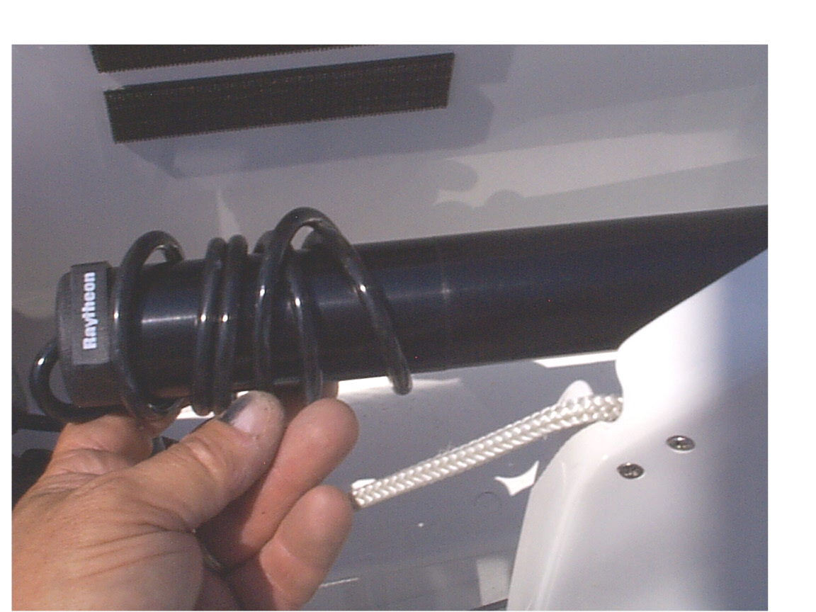

* If the Joystick Module will be mounted for RIGHT HAND operation, coil the excess power cable around the EV100 Drive Motor housing as shown. Leave an 8” tail on the power cord.
* If the Power-Assist Joystick Module will be mounted for LEFT HAND operation, route the power cable from the EV100 Drive Motor down under the seat and up to the shelf to the left of the sailor. NOTE: make sure that the cable does not interfere with the steering lines, and that a Sailing Companion in the rear seat will not fowl the cable with his/her feet.

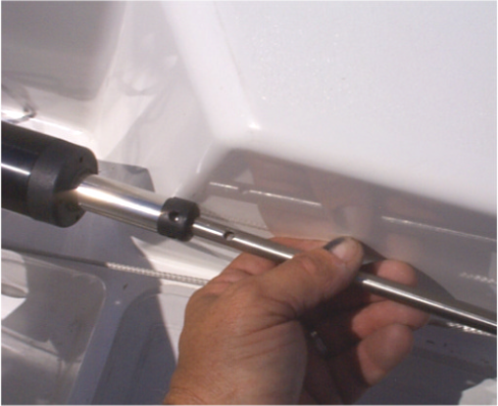

* Place the pin on the EV100 Drive Motor in the pedestal socket, and then lead the power cord and press it snuggly into the connector marked “HELM DRIVE” on the rear of the Power-Assist Joystick Module.
* Remove the EMERGENCY DISENGAGE FAST PIN, align and insert the Tiller Rod in the hole in the end of the EV100 drive. Twist to align the holes and insert the FAST PIN from the top. To avoid scratching the finish of the boat, the pin should be oriented VERTCALLY when in place.

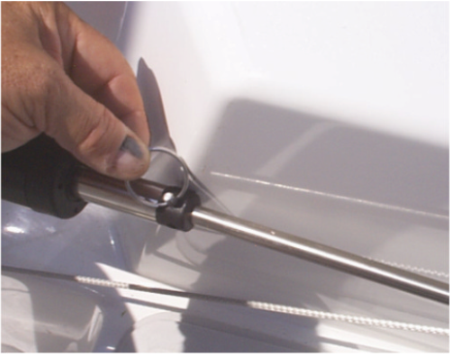

* NOTE: In an emergency, this FAST PIN may have to be removed quickly to revert to manual steering. Test it a couple of times to assure that it can be removed easily.

## Upper-body Support Harness



*Paraplegic, quadriplegic or hemiplegic sailors may wear the Upper Body Support Harness in weather and sea conditions where additional upper body support is required.*

*The Upper Body Support Harness is “color-coded”: the GREEN webbing loop installs to the “starboard” (right) side of sailor; the RED webbing loop installs to the “port” (left) side of the sailor.*

**Donning the Upper-body Support Harness**

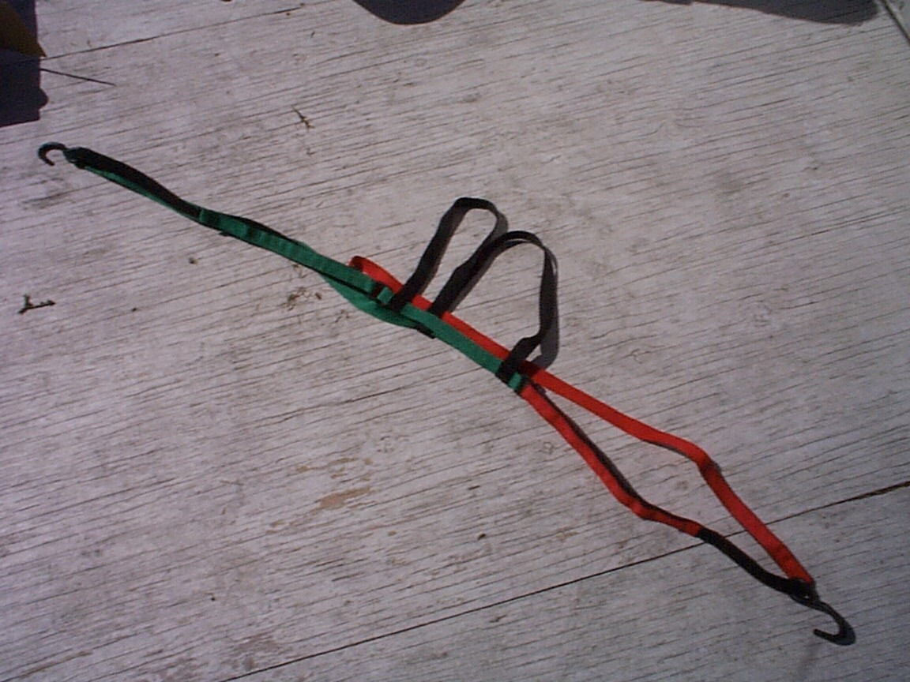

* First, orient and then pick up the harness so that the GREEN webbing with the HOOK is to the right of the sailor, and the RED to the left. Place it over the sailor’s head, from behind, with one BLACK shoulder strap on each shoulder of the sailor.

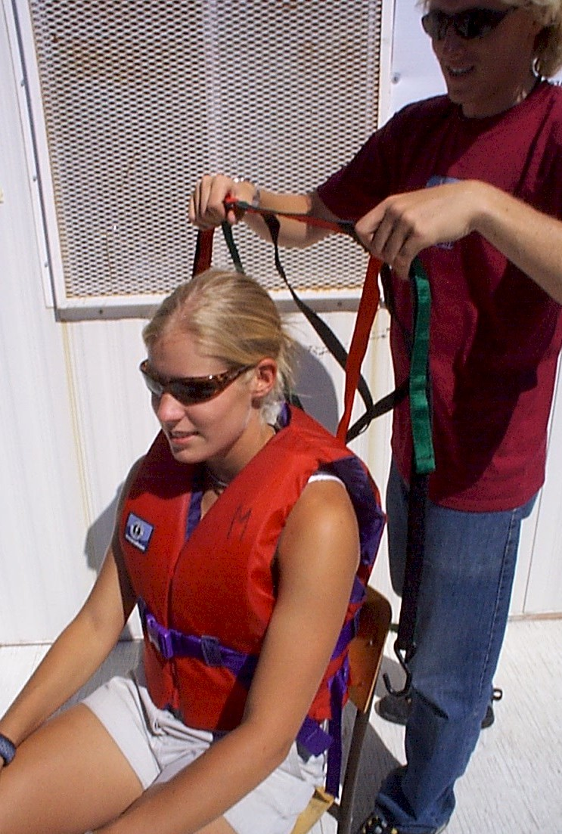

* There are now two straps over each arm. The INNER STRAPS (the strap without a hook) goes UNDER the sailors arm, supporting the armpit. The GREEN INNER STRAP goes under the LEFT ARM. The RED INNER STRAP goes under the RIGHT ARM.
* The OUTER STRAPS (the straps WITH a HOOK) go on TOP of the sailor’s arms. The GREEN strap is extended to the RIGHT gunwale of the boat, placing the HOOK under the gunwale. Similarly, the RED strap is extended to the LEFT gunwale of the boat, placing the hook under the gunwale. Place the hooks slightly BEHIND the sailor’s body.

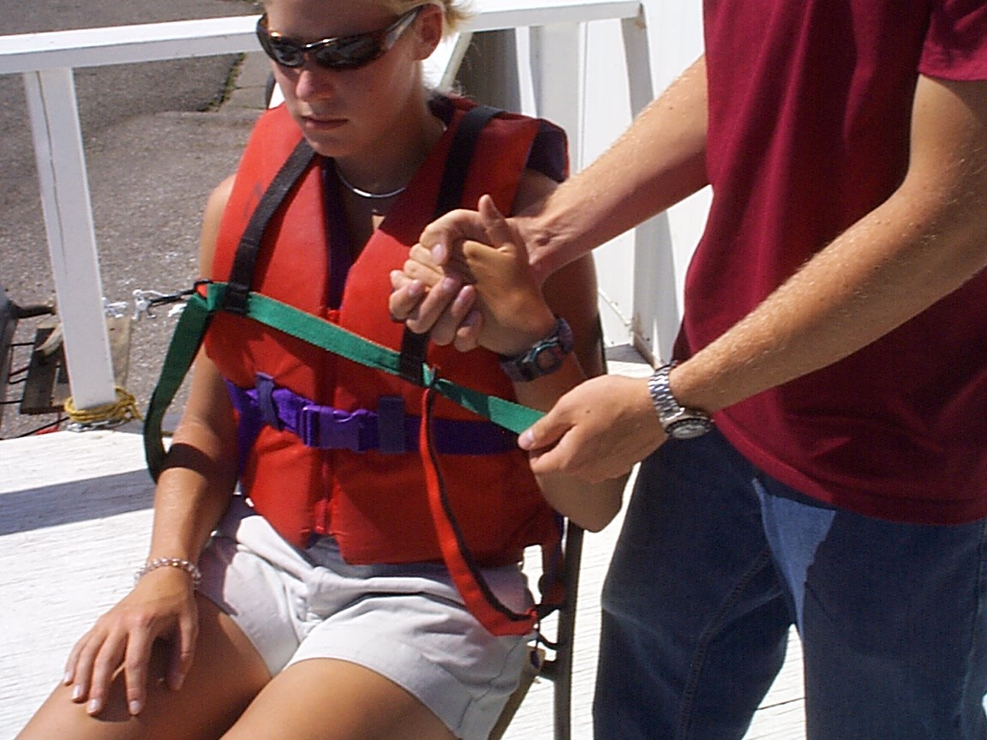

* The Harness straps may be individually adjusted to provide support for the sailor. Release the velcro fasteners on the front of the straps to snug and center the harness. To provide support, the straps need to relatively TIGHT. They may loosen while sailing, and need to be tightened periodically.

## Before you go sailing…

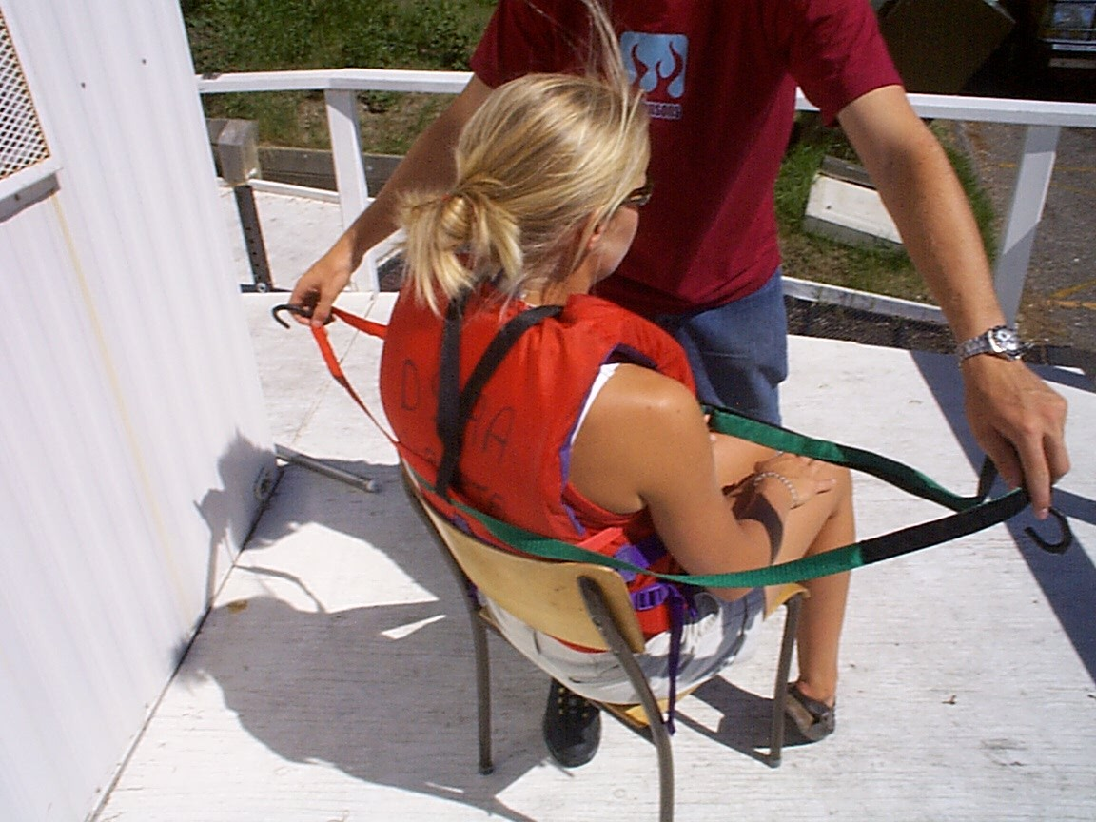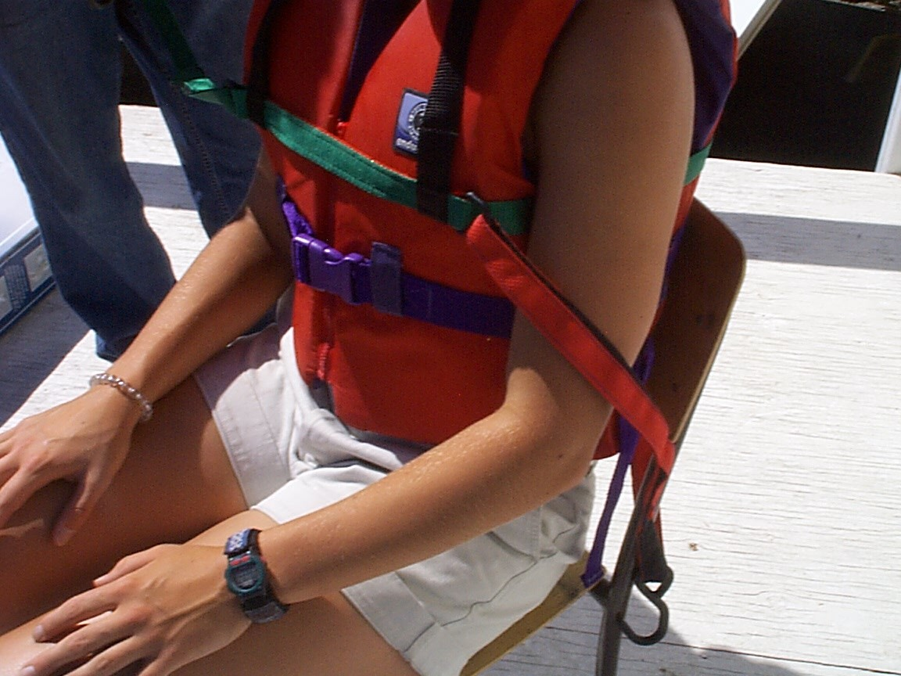

When the Power-Assist System components have been installed, perform the following functional tests of the system at the dockside.

**Adjust the JIB SLOT TRIM sheet**

The Windlass adjusts both sails in unison. It is important that the RELATIVE position of the jib sail with respect to the main sail be adjustable. This is done by adjusting the JIB TRIM sheet as follows.

* RELEASE the JIB TRIM sheet from the cleat located at the TOP LEFT of the Cleat Console.
* Operate the joystick FORWARD momentarily. The Winch should operate, letting both the JIB SHEET and MAIN SHEET “out”, spooling line off of the drums.
* Now check that both sails are clear to move (release the MAIN BOOM PREVENTER clip from the shroud so that the main boom swings freely)
* Operate the joystick BACK, spooling in both the main and jib sheets smoothly onto both winch drums (clear snags and tangles in the sheets as required). Operate the Windlass until both sails come to the centerline of the boat. If one sail comes to the centerline before the other, tighten or release the JIB SLOT TRIM sheet so that they both come to the centerline at the same time. Cleat the JIB SLOT TRIM sheet.

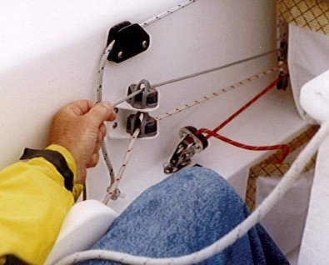

* Once adjusted, for safety while on the dock, operate the Windlass to let both sheets all the way OUT. Then clip the MAIN BOOM PREVENTER to the shroud.
* Fine adjustments may be made to the JIB SLOT TRIM at any time while sailing.

**Check (manual) Joystick is Centered**

While using power-assisted steering, the manual JOYSTICK (in front of sailor) provides an important visual indicator of the position of the rudder. It’s important to check that it is properly centered before you leave the dock:

* Operate the Power-Assist System joystick to move the RUDDER to a centered position. Now look at the (manual) JOYSTICK. If it is NOT centered, adjust the STEERING LINES on the aft deck until it is centered.

**Check Tiller Rod is Centered**

While using power-assisted steering, the action of the steering must be centered to avoid loosing control or damage to the mechanics.

* Check that there is nothing in the way of the JOYSTICK (the sailor’s hands or legs), the tiller or the rudder. Operate the joystick to move the rudder all the way to PORT. WATCH THE ACTION OF THE TILLER ROD AND RUDDER and if it seems to be stressed in any way, STOP! If it is adjusted correctly, the M16 Tiller will reach its maximum travel when it is about ½” from the block on the aft deck.
* Now operate the joystick to go all the way to STARBOARD. If it is adjusted correctly, the M16 Tiller will reach its maximum travel when it is about ½” from the block on the aft deck
* If the action of the rudder is not centered (i.e. more to either PORT or STARBOARD), loosen the lock nut on the Tiller Rod and adjust the length of the rod to center the action.

**Check Sip&Puff Module operation**

If you are using Sip&Puff, ask the sailor to check the HELM and WINDLASS operation via the Sip&Puff interface. Check that the Sip&Puff Stalk is securely fastened to the sailor’s lifejacket and that it may not be jarred loose while sailing. Check that the Sip&Puff Module is securely fastened to the cockpit wall and that it may not be jarred loose while sailing.

## Warning to Operator

The Martin 16 Power-Assist System is an ASSISTIVE DEVICE, intended to assist sailors with limited hand function to operate sailboats independently.

The fabricator provides no specific warranties or claims of the Martin 16 Power-Assist System’s "fitness for use" for any person, on any vessel or sailing conditions. Sailing is a dangerous sport, and the operator uses the Martin 16 Power-Assist System at his/her own risk. Operators are responsible for receiving proper training in the use of the Martin 16 Power-Assist System and for taking normal and appropriate precautions while using the system.

Always have able-bodied person on board your vessel so that, in conditions of inclement weather or when emergency maneuvers are required, they may disengage the Martin 16 Power-Assist System and steer the boat manually. If the Martin 16 Power-Assist System malfunctions for any reason while sailing, always be prepared to revert to manual steering control.

## Caution while sailing

Over 20 years of daily use in a wide variety of sailing venues, wind and sea state conditions, the Power-Assist System has proven to provide reliable power-assisted steering and sheeting control of a Martin 16 sloop. The system allows sailors with significant disabilities to safely and independently control their Martin 16. Nevertheless, the system does not provide the same level of response, feedback and “feel” that manual systems do. Sailors are required to be prudent in their use of the equipment and follow these safety precautions:

* The Power-Assist System will not respond to steering commands as quickly as the helm may be turned manually (Hard-over-PORT to Hard-over-STARBOARD takes about 6 seconds). Be aware of this limitation and be cautious when maneuvering at slow speeds around docks, or in close proximity to other boats or hazards.
* The Power-Assist System and Windlass electric motors are powerful enough to cause harm to clothing and paralyzed limbs. Make sure that the sailor’s clothing and paralyzed limbs are clear of the action of the Windlass and the Joystick when under power assist.
* In heavy winds and waves, the system will draw more power and the battery will discharge more quickly. Always be prepared to revert to manual operation if required at any time.
* In the event that the Power-Assist System malfunctions for any reason while sailing, always be prepared to revert to manual steering control by removing the EMERGENCY DISENGAGE FAST PIN on the HELM DRIVE Motor. Sailors not capable of doing this on their own should always sail with an able-bodied Sailing Companion.
* In the event that the WINDLASS malfunctions for any reason while sailing, always be prepared to revert to manual sheeting by pulling the EMERGENCY RELEASE PINS on each of the winch drums. Once released, the drums rotate freely allowing manual sheeting. Sailors not capable of doing this on their own should always sail with an able-bodied Sailing Companion.
* Power-Assist Systems are often used in Disabled Sailing Programs shared among a number of sailors and operated by volunteer staff. It is recommended that ONE mechanically-oriented person be made responsible for a shared system, to assure that the system is properly maintained and that sailors and volunteers receive the necessary training in safe use of the Systems.

## Caring for your M16 Power-Assist System

* ***When not in use, remove and store the System Modules****. The Power-Assist System Modules are intended to be removed from the boat and stored in a cool, dry place when not in use. DO NOT LEAVE THE COMPONENTS ON THE BOAT OR OUTSIDE IN THE WEATHER WHEN NOT IN USE.*
* ***CAUTION: Power-Assist Modules are NOT warranted against water damage.*** *The Power-Assist Joystick Module is a sensitive computer product subject to harsh conditions. Under good care, these Modules are water tight and will operate reliably for years of service. However, due to the number of exposed electrical connectors, a harsh operating environment and susceptibility to abuse, the Power-Assist Modules are not warranted against water damage.*

*In order to maintain the integrity of the weatherproof seals in the system:*

* ***REPLACE*** *caps over electrical connectors when they’re not in use.*
* ***RINSE*** *the entire system with fresh water after sailing. DO NOT use a high-pressure hose. Wipe the components down with a dry rag before storing. NOTE: This is very important when used in salt water.*
* ***INSPECT and CLEAN CONNECTORS*** *periodically, and spray with a moisture displacing fluid such as BOESHIELD T-9 (available at WEST MARINE stores) before storing the system.*
* ***PROTECT the Joystick*** *– it is a mechanically sensitive switching device. Be careful to protect it from impact and abuse when using the system, when transporting it, and when it’s stored. Check the integrity of the rubber “bellows” on the Joystick for cracks or cuts and replace it if necessary.*

## Warranty



The Martin 16 Power-Assist System is fabricated of high-quality marine components by Steve Alvey of Pender Island, BC. I have made 130+ systems over the past 25 years, used by sailors all over the globe. The systems have proven robust and reliable; Serial # 001 (1998) is still in service.

The Power Assist System is warranted for 1 year from the date of shipment.

No warranty is provided for:

* the battery
* water damage to electronic components.
* mechanical damage to any component that results from neglect or abuse.

Systems must be shipped back to Steve Alvey for warranty repairs.

**If your Power-Assist System does not operate as expected, please call or e-mail:**

**Steve Alvey 403-870-7210 (**[**steve@imlcontracting.ca**](mailto:steve@imlcontracting.ca)**).**

***Fair Sailing!***

## Appendix A: Spare / Replacement parts

|  |  |  |
| --- | --- | --- |
| **Part #** | **Description** | **Location** |
| A134 | Raymarine EV-100 HELM DRIVE | rudder drive |
| A700 | Helm Drive Pedestal Mount (D030) | Mounting socket |
| A137 | Tiller pushrod | Pushrod |
| A138 | pushrod turnbuckle end | pushrod turnbuckle end |
| A140 | 3/16" fastpin | 3/16" fastpin |
| A141 | Martin 16 Tiller cross arm | rudder head |
| W204 | Windlass power cable assembly | windlass |
| BM596 | EarthX LITHIUM Battery | Battery module |
| BM599 | Battery Module (complete) |  |
| BC699 | Intelligent Lithium Battery Charger |  |
| S398 | Sip & Puff stalk with chest mounting plate (personal) | |
| A807 | Upper Body Support Harness | |
| A123 | Joystick Module – Mk VI PCB |  |
| A103 | Joystick Module – replacement joystick |  |
| S330 | Sip & Puff Module – pneumatic switch PCB | |
| S398 | Sip & Puff stalk with chest mounting plate (personal) | |
| P1600 | Pelican 1610 custom shipping case |  |

**To order spare or replacement parts, contact:**

Steve Alvey 403-870-7210 [**steve@imlcontracting.ca**](mailto:steve@imlcontracting.ca)